
Ministry of High Education
Al-Obour Institutes for Engineering and Technology
Department of Electronics and Communication

Life Guard
Smart Health Monitoring System
GRADUATION PROJECT
Prepared By:
Mohamed Adel Mohamed Hussein
Mohamed Hossam Abdelsalam
Mohamed Hassan Moustafa
Mohamed Gamal Hamed
Mohamed Adel Fouad
Mohamed Adel Lotfy
Ahmed Bahaa El-Din
Karim Wael Osman
Ziad Reda Fahmy

Supervised By
Dr. Sally Abdulateef El Gindy

2026

Acknowledgements

الحمد لله رب العالمين، الذي بنعمته تتم الصالحات، وبفضله تذلل الصعاب، وتتحقق الآمال. الحمد لله الذي وفقنا لإتمام هذا المشروع، ومنحنا القوة والصبر والعزيمة خلال رحلة البحث والدراسة.
ومن هنا نتقدم بخالص الشكر والامتنان إلى الدكتورة/ سالي عبداللطيف الجندي، على إشرافها الكريم وتوجيهاتها السديدة منذ بداية هذا المشروع وحتى نهايته. لقد كان لدعمها المستمر، وملاحظاتها الدقيقة، ونصائحها الغنية أثر بالغ في تطوير هذا العمل وصقله أكاديميًا ومنهجيًا. فله مني كل التقدير والاحترام.
كما نود أن نعبر عن عميق امتناننا إلى أعضاء هيئة التدريس المحترمين في قسم هندسة الإلكترونيات والاتصالات الكهربية، الذين لم يبخلوا علينا بعلمهم، وكانوا دائمًا مصدر إلهام وتحفيز طوال سنوات الدراسة، وأسهموا في إثراء معارفنا ومداركنا العلمية والعملية.
كما نود ان نشكر كل القائمين على المعهد العالي للهندسة والتكنولوجيا بالعبور وعلى رأسهم معالي الاستاذ الدكتور/ عبدالله الدهشان، وسيادة عميد المعهد الأستاذ الدكتور/ مجدي زهو ورئيس قسم هندسة الإلكترونيات والاتصالات الكهربية بالمعهد سيادة الاستاذ الدكتور / إبراهيم فتحي طراد ، وفقهم الله الي ما فيه الخير والصلاح.
ولا يفوتنا أن نتوجه بخالص الشكر والعرفان إلى أسرتنا العزيزة، التي كانت السند الحقيقي والداعم الأول في هذه المسيرة. إلى والدينا الكرام، شكرًا لصبركما، ودعائكما، وثقتكما الدائمة بنا. لقد كنتم دائمًا النور الذي أنار طريقنا في أوقات التحديات. كما نخص بالشكر إخوتنا وأخواتنا الذين لم يتوانوا يومًا عن منحنا كلمات التشجيع والتحفيز.
كما نتقدم بجزيل الشكر إلى زملائي وزميلاتنا الذين شاركونا هذه الرحلة الجامعية، ووقفوا إلى جانبنا خلال فترات العمل على المشروع، وكانوا مثالًا في التعاون وتبادل الخبرات.
ولا ننسى أن نذكر بالعرفان كل من ساعدنا أو قدّم لنا المعلومة، أو أتاح لنا الفرصة للحصول على مصادر وبيانات كان لها أثر كبير في إنجاز المشروع، سواء من داخل الجامعة أو خارجها.
أخيرًا، نسأل الله تعالى أن يجعل هذا العمل خالصًا لوجهه الكريم، وأن ينفع به كل من يطّلع عليه، وأن يكون خطوة أولى في مسيرة علمية وعملية مليئة بالنجاح والعطاء.
Abstract
In recent years, the integration of the Internet of Things (IoT) in healthcare has significantly advanced remote patient monitoring. However, a critical challenge remains the "delayed rescue" phenomenon during sudden medical emergencies, such as falls or abnormal vital fluctuations, particularly among elderly and vulnerable individuals. This project introduces "LifeGuard," an autonomous, AI-driven Smart Health Monitoring System integrated into an ergonomic wearable vest.

The system continuously tracks vital physiological parameters—including heart rate, blood oxygen saturation (SpO2), core body temperature, and electrocardiogram (ECG) signals—alongside a 6-axis motion sensor for precise fall detection. Driven by an ESP32 edge microcontroller, the hardware transmits real-time telemetry to a robust cloud architecture powered by the n8n workflow automation platform.

Upon detecting critical medical thresholds or physical anomalies, the cloud infrastructure instantly archives the data into a secure Electronic Health Record (EHR) and triggers a Large Language Model (Gemini AI) acting as a medical triage assistant. The AI dynamically generates contextual first-aid instructions, which are dispatched with zero latency to caregivers via the Telegram API. Furthermore, a custom REST API feeds a lightweight mobile application, providing a real-time monitoring dashboard. Ultimately, LifeGuard successfully eliminates human dependency in the alerting phase, offering a proactive, reliable, and intelligent healthcare guardian.

إقرار
نقر نحن الطلاب التالي أسمائهم:
- محمد عادل محمد حسين ٢٢١١٤٨
- محمد عادل فؤاد ٢٢١٣٢٣
- محمد عادل لطفي ٢٢٠١٦١
- زياد رضا فهمي ٢٢١٠٧٦
- احمد بهاء الدين ٢٢١٣٩٩
- محمد حسن مصطفي ٢٢١١٣٢
- محمد جمال حامد ٢٢١٣٢٤
- كريم وائل عثمان ٢٢١٠٥٣
- محمد حسام عبدالسلام ٢٢١٢٠٦
باننا قمنا بعمل مشروع
Life Guard
Smart Health Monitoring System
وذلك بالمعهد العالي للهندسة والتكنولوجيا بالعبور خلال العام الدراسي 2025/2026

وذلك تحت اشراف:
الدكتورة /سالي عبد اللطيف الجندي
وهذا إقرار منا بذلك
Table of Content

Chapter One: Introduction…………………………………………………. 1
1.1 Overview 2
1.2 Problem Statement 2
1.3 Project Idea 3
1.4 Objective of the Project 4
1.5 Let’s talk about IoT Wearable Health Monitors 5
1.5.1 The Meaning of Smart Wearable Health Systems 5
1.5.2 Evolution of IoT in Healthcare 5
1.5.3 Importance and Applications 5
1.5.4 Core Components of a Smart Medical Vest 6
1.5.5 The Mechanism of IoT Medical Wearables 6
1.5.6 The Reason of Choosing ESP32 Microcontroller 7
1.5.7 Comparison Table: ESP32 vs Alternatives 7
1.5.8 Connectivity Technologies for IoT Health 7
1.5.9 Advanced Features (AI Decision Support) 8
1.5.10 Challenges and Solutions 8
1.5.11 Future Prospects of Medical Wearables 8
1.5.12 Security and Patient Privacy Considerations 8
1.5.13 Smart Vest vs Traditional Medical Monitors 9
1.6 Project Structure 9
1.7 Conclusion 10

Chapter Two: OVERVIEW 11
2.1 Overview 12
2.2 Main Components of the System 12
2.2.1 Wearable Smart Vest Fabric 12
2.2.2 Processing Unit (ESP32) 12
2.2.3 Medical Sensor Array 13
2.2.4 Cloud Automation Server (n8n) 13
2.3 Principle of Operation 13
2.4 Features and Capabilities 13
2.4.1 Real-Time Vital Signs Tracking 13
2.4.2 Intelligent Fall Detection 13
2.4.3 AI-Powered Emergency Alerts 13
2.4.4 Continuous Historical Logging 13
2.4.5 Mobile Dashboard Integration 14
2.5 Practical Applications of the LifeGuard System 14
2.5.1 Elderly Care and Independent Living 14
2.5.2 Hospitals and Remote Patient Monitoring 14
2.5.3 Rehabilitation Centers 14
2.6 Temperature (MLX90614) Sensor 15
2.6.1 Key Features of the MLX90614 Sensor 16
2.6.2 Enhancing System Functionality Through the Sensor 16
2.7 Heart Rate & SpO2 (MAX30105) Sensor 17
2.8 Motion and Fall Detection (MPU6050) Sensor 17
2.9 ECG Cardiac Monitor (AD8232) Sensor 18
2.10 ESP Microcontroller 19
2.10.1 Definition 19
2.10.2 How It Works 19
2.10.3 Types of ESP Microcontrollers 20
2.10.4 Comparison Between Types of ESP Microcontrollers 20
2.10.5 Why ESP is Popular in IoT Projects 21
2.11 Comparison between ESP32 and Arduino Uno 22
2.12 Cloud Automation (n8n) and Webhooks 23
2.13 Power Supply and Battery Management 24
2.14 Jumper Wires and Wearable Conductive Fabric 24
2.14.1 Cable Management in Wearable Tech 25
2.14.2 Types of Connections Used in the Smart Vest 25

CHAPTER THREE: LITERATURE REVIEW 26
3.1 Overview 27
3.2 Applications of IoT-Based Patient Monitoring Systems 27
3.2.1 General Vital Signs Monitoring Field 27
3.2.2 Fall Detection Field 30
3.2.3 Cloud Connectivity and Alert Systems Field 31
3.2.4 AI-Assisted and Intelligent Triage Field 33
3.3 Summary 34

CHAPTER FOUR: HARDWARE 35
4.1 Overview 36
4.2 LifeGuard System Architecture 36
4.3 Smart Vest Ergonomics and Component Placement 37
4.4 Edge Processing Unit (ESP32 Dev Module) 38
4.5 Sensors Configuration 39
4.5.1 Body Temperature Sensor (MLX90614) Placement 39
4.5.2 Heart Rate & SpO2 Sensor (MAX30105) Placement 40
4.5.3 Fall Detection Sensor (MPU6050) Placement 40
4.5.4 ECG Sensor (AD8232) Placement 41
4.6 Power Management and Battery Sizing 41
4.7 Components of the Hardware Assembly 42
4.7.1 Central Control Box (3D Printed Enclosure) 42
4.7.2 Medical-Grade Conductive Pads 42
4.7.3 Internal Fabric Conduits for Wiring 42

CHAPTER FIVE: SOFTWARE 44
5.1 Overview 45
5.2 Edge Firmware Implementation (C++ on ESP32) 45
5.2.1 I2C Communication and Sensor Initialization 46
5.2.2 Signal Processing and Net Acceleration Algorithm 47
5.2.3 JSON Payload Construction and HTTP POST Requests 48
5.3 Cloud Automation Architecture (n8n) 49
5.3.1 Webhook Configuration for Data Ingestion 49
5.3.2 Data Parsing and Error Handling (JavaScript) 50
5.3.3 Database Logging (Google Sheets Integration) 51
5.4 AI Integration and Emergency Routing 52
5.4.1 Gemini AI Prompt Engineering for Medical Triage 52
5.4.2 Telegram Bot API for Instant Alerts 53
5.5 Caregiver Mobile Application and API 54
5.5.1 REST API (GET Webhook) Implementation 54
5.5.2 Real-Time Dashboard UI Synchronization 55

CHAPTER SIX: CONCLUSION & FUTURE WORK 57
6.1 Conclusion 58
6.2 Future Work 59
References 61

Chapter One Introduction

1.1 Overview
Healthcare monitoring has become one of the most important applications of the Internet of Things (IoT). Elderly individuals, patients with chronic diseases, and people with limited mobility often require continuous observation of their health conditions. Traditional monitoring methods usually depend on periodic medical checkups and manual supervision, which may not provide immediate responses during emergencies.
The Life Guard Smart Health Monitoring System is an innovative wearable healthcare solution designed to provide real-time monitoring of vital signs and physical activities. The system integrates advanced medical sensors with an ESP32 microcontroller to continuously collect and process health data. By utilizing cloud automation, artificial intelligence, and instant notifications, the system enables caregivers to monitor patients remotely and respond quickly to critical situations.
The proposed system aims to improve patient safety, reduce medical risks, and provide peace of mind for both patients and caregivers through continuous health supervision and emergency alert mechanisms.
1.2 Problem Statement
Many elderly individuals and patients with limited mobility face serious health risks due to the lack of continuous medical monitoring. Sudden falls, abnormal heart rates, low oxygen saturation levels, and body temperature abnormalities may occur without immediate detection, leading to delayed medical intervention.
Traditional healthcare monitoring methods often require constant human supervision, which is not always practical or available. In addition, caregivers may not be physically present when emergencies occur.
Therefore, there is a need for a smart, reliable, and cost-effective health monitoring system capable of continuously tracking vital signs, detecting emergencies, and automatically notifying caregivers in real time.

1.3 Project Idea
The Life Guard Smart Health Monitoring System is a wearable IoT-based healthcare solution designed to monitor patients continuously and remotely. The system collects physiological and movement data using multiple sensors, including heart rate, blood oxygen saturation, body temperature, ECG monitoring, and motion detection sensors.
The ESP32 microcontroller processes the sensor readings and transmits the data to a cloud-based automation platform through Wi-Fi connectivity. The collected information is stored for future analysis while intelligent decision-making algorithms evaluate the patient's condition.
Whenever abnormal readings or emergency situations such as falls are detected, the system automatically generates alerts and sends instant notifications to caregivers through Telegram. This enables rapid response and improves patient safety.
  - Objective of the Project
The main objectives of this project are:
- To develop a wearable healthcare monitoring system.To continuously monitor vital signs in real time.
- To detect falls and abnormal movements automatically.
- To provide remote monitoring capabilities for caregivers.

- To store patient data for future analysis and tracking.
- To generate instant emergency alerts using cloud automation.
- To integrate artificial intelligence for intelligent health assessment.
- To improve patient safety and quality of healthcare services.
- To create a cost-effective and scalable healthcare solution.

1. Let's Talk About the Smart Health Monitoring System Using ESP32

Modern healthcare is rapidly evolving with the integration of Internet of Things (IoT) technologies. Smart Health Monitoring Systems have emerged as powerful solutions that enable continuous monitoring of patients without requiring constant hospital visits. By combining wearable sensors, wireless communication, cloud services, and artificial intelligence, these systems provide real-time health supervision and immediate emergency response. The Life Guard Smart Health Monitoring System is an example of this innovation, utilizing the ESP32 microcontroller and multiple medical sensors to enhance patient safety and healthcare efficiency.

1.5.2 Evolution of Smart Health Monitoring Systems

Healthcare monitoring has evolved from traditional manual observation to advanced digital systems. Early monitoring methods relied on periodic medical examinations and hospital-based equipment. With the emergence of IoT, wearable technology, cloud computing, and artificial intelligence, healthcare monitoring systems have become portable, connected, and capable of providing real-time medical insights. Modern systems can now detect emergencies automatically and notify caregivers instantly.

1.5.3 Importance and Applications
Smart Health Monitoring Systems play a significant role in modern healthcare by improving patient safety and reducing medical risks.

Their applications include:
- Monitoring elderly individuals living alone.
- Supervising patients with chronic diseases.
- Remote healthcare services.
- Fall detection and emergency response.
- Home healthcare monitoring.
- Post-surgery patient observation.
- Continuous health tracking for high-risk individuals

1.5.4 Core Components of a Smart Health Monitoring System

The main components of the proposed system include:
- ESP32 Microcontroller.
- Heart Rate and SpO₂ Sensor (MAX30105).
- Temperature Sensor (MLX90614).
- Motion and Fall Detection Sensor (MPU6050).
- ECG Sensor (AD8232).
- Wi-Fi Communication Module.
- Cloud Automation Platform (n8n).
- Artificial Intelligence Engine (Gemini AI).
- Caregiver Mobile Application.
- Data Storage Platform (Google Sheets).

1.5.5 he Mechanism of Smart Health Monitoring Systems

The system operates through a sequence of interconnected processes. Medical sensors continuously collect physiological data from the patient. The ESP32 processes the raw sensor readings and transmits them to the cloud through Wi-Fi. The cloud platform stores the data, evaluates health conditions, and applies predefined thresholds. If an abnormal event such as a fall or dangerous vital sign is detected, an alert is generated and immediately delivered to caregivers through Telegram notifications and the mobile application.

1.5.6 The Reason for Choosing ESP32

The ESP32 was selected because it provides several advantages:
- Built-in Wi-Fi and Bluetooth connectivity.
- Dual-core processor for multitasking.
- Low power consumption suitable for wearable devices.
- High processing performance.
- Large number of GPIO pins.
- Cost-effectiveness.
- Strong support from the developer community.
Feature | ESP32 | Raspberry Pi | Arduino Uno
Operating System | RTOS Or without | Linux | Without
Built-in Wi-Fi/Bluetooth | Yes | No | Yes
Processing Speed | High | Very high | Moderate
Power Consumption | Moderate | Very Low | High
Cost | Low | Higher | Low
Iot Suitability | Excellent | Good | Limited
Wearable Applications | Excellent | Moderate | Moderate

1.5.7 Comparison Table: ESP32 vs Raspberry Pi vs Arduino Uno

1.5.8 Technologies Used in the Smart Health Monitoring System
- Several advanced technologies are integrated into the proposed system:
- Internet of Things (IoT).
- Embedded Systems.
- Wireless Communication.
- Cloud Computing.
- Artificial Intelligence.
- Mobile Application Development.
- Real-Time Data Processing.
- Medical Sensor Integration.
1.5.9 Advanced Features
- The Life Guard system offers several advanced features:
- Real-time health monitoring.
- Intelligent fall detection.
- AI-powered emergency analysis.
- Remote caregiver access.
- Historical health data storage.
- Instant Telegram notifications.
- Cloud-based automation.
- Wearable and portable design
1.5.10 Challenges and Solutions
Challenge: Sensor noise and inaccurate readings.
Solution: Signal filtering and calibration techniques.
Challenge: Real-time communication delays.
Solution: Efficient cloud automation through n8n workflows.
Challenge: Reliable fall detection.
Solution: Acceleration vector calculations using MPU6050.
Challenge: Remote accessibility.
Solution: Web dashboard and mobile application integration.
.

1.5.11 Future Prospects of Smart Health Monitoring Systems
Future developments may include:
- Advanced ECG interpretation.
- AI-assisted diagnosis.
- Predictive healthcare analytics.
- Digital Twin technology.
- Stress and emotion analysis.
- Integration with hospitals and healthcare databases.
- Federated Learning for enhanced privacy.
- GPS-based emergency location tracking.
.

1.5.12 Security and Privacy Considerations

Because medical information is highly sensitive, security measures are essential. The system must ensure secure communication channels, controlled data access, user authentication, and data encryption. These measures help protect patient privacy and maintain the confidentiality of healthcare information.

1.5.13 Smart Health Monitoring System vs Other Smart Devices
Unlike traditional smart devices that primarily focus on convenience and automation, Smart Health Monitoring Systems are specifically designed to monitor human health and support medical decision-making. They provide continuous health tracking, emergency detection, caregiver communication, and healthcare analytics, making them significantly more valuable in critical healthcare applications..

1.6 Project Structure
- This report is organized into several chapters.
- Chapter One introduces the project and presents its objectives and background.
- Chapter Two discusses the overview of the project.
- Chapter Three explains the literature review and related technologies.
- Chapter Four describes hardware architecture and the system design.
- Chapter Five describes software implementation and cloud integration. Finally,
- Chapter Six provides conclusions and recommendations for future improvements.

1.7 Conclusion
This chapter introduced the Life Guard Smart Health Monitoring System and discussed its objectives, significance, and technological foundations. The project demonstrates how IoT, cloud computing, artificial intelligence, and wearable medical sensors can be combined to create an effective healthcare monitoring solution. The following chapters provide a detailed explanation of the design, implementation, and evaluation of the proposed system.

Chapter Two OVERVIEW

2.1 Overview
The hardware components of a LifeGuard Vest using the ESP32 microcontroller typically include several key elements that enable its functionality as both a wearable biomedical device and an interactive, cloud-connected healthcare system. Here’s an overview of the essential hardware components commonly found in the Lifeguard system as shown in Fig. 2.1.
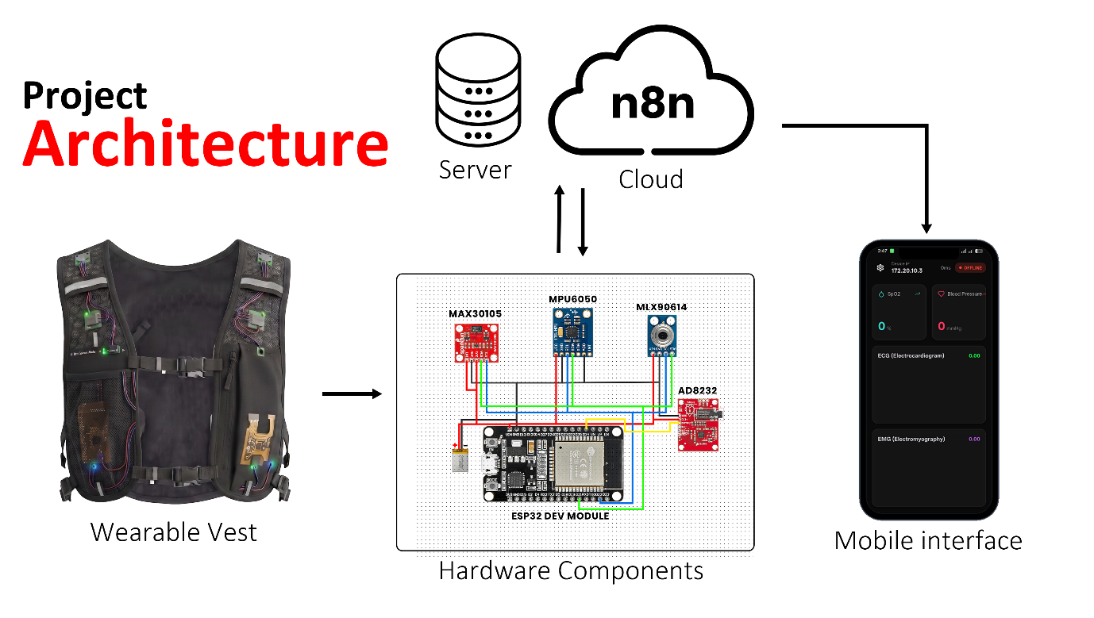
Figure 2.1 : Lifeguard Smart Vest System Architecture

2.2 Main Components of the System
The smart health monitoring vest consists of several key components that work together to deliver a fully integrated, real-time patient monitoring experience. These components include:

2.2.1 Smart Vest (Wearable Fabric)
The structural garment is made of comfortable, breathable fabric that safely houses, secures, and protects the internal electronics and routing buses while maintaining a natural, ergonomic fit for continuous, long-term patient wear.

2.2.2 Processing Unit (ESP32 Dev Module)
The ESP32 acts as the core processing and edge computing unit. It manages sensor data polling via hardware buses, processes algorithms locally (such as fall detection), and utilizes its built-in WiFi connectivity to securely transmit data to the cloud..

2.2.3 Sensor Array (Biomedical and Inertial Hub)
A specialized group of sensors embedded within the vest to gather physiological and movement data:
- MLX90614: An infrared thermometer for non-contact core body temperature tracking.
- MPU6050: A 3-axis accelerometer and gyroscope used to monitor orientation and detect sudden physical impacts.
- MAX30105: An optical sensor designed for high-accuracy heart rate and blood oxygen saturation (SpO_2) analysis.
- AD8232: A dedicated single-lead heart rate monitor that captures cardiac electrical bio-potentials (ECG)..

2.2.4 Power Source (Lithium Polymer Battery)
A rechargeable 3.7V Lithium Polymer (Li-Po) battery that provides stable, portable, and long-lasting power to the ESP32 and its attached sensor array, ensuring uninterrupted operational mobility.

2.3 Principle of operation
The smart monitoring vest operates by continuously collecting raw physiological and motion data from the sensor array via the I2C and analog pins of the ESP32. To optimize bandwidth and ensure immediate response times, the ESP32 acts as an edge computing node, running local filters and calculating the mathematical resultant acceleration vector.

Once processed, the variables are structured into a lightweight JSON payload and transmitted via secure HTTPS POST requests to a public n8n cloud server. The cloud platform acts as the workflow orchestrator, dynamically updating the user web dashboard, logging historical baselines into Google Sheets, and passing contextual metrics to Gemini AI for intelligent clinical assessment.

2.4 Features and Capabilities

    - Real-Time Vitals Tracking
Provides continuous and highly accurate telemetry of core body temperature, heart rate (BPM), and blood oxygen levels (SpO_2) to monitor patient stability.
    - Electrocardiogram (ECG) Acquisition
Captures and prepares detailed cardiac bio-potential charts, allowing medical professionals to review heart rhythm patterns remotely.
    - Edge-Based Fall Detection
Utilizes the onboard inertial sensor to compute instantaneous 3D acceleration changes via the vector formula: NetAcc = sqrt{a.x^2 + a.y^2 + a.z^2}
This mathematical processing allows the system to recognize accidental falls instantly and independently of cloud latency.
    - AI-Powered Health Summaries
Integrates Gemini AI within the cloud workflow to evaluate daily physiological trends contextually, translating raw numbers into descriptive, human-readable medical overviews.

    - Automated Emergency Alerting
Triggers immediate, context-rich push notifications to caregivers' Telegram accounts the moment a critical vital anomaly or sudden fall is detected.

2.5 Practical Applications of the LifeGuard
The smart monitoring vest is highly versatile and can be effectively deployed in various healthcare settings, including:

    - Elderly and Remote Home Care
Provides independent living support for elderly individuals by offering non-invasive, continuous monitoring, and instant accident alerts for families and private caregivers.
    - Post-Operative Rehabilitation
Tracks recovery metrics, mobility levels, and cardiac stability for patients transitioning from intensive hospital care to home-based rehabilitation.
    - Decentralized Clinical Wards
Serves as a cost-effective, wireless telemetry solution for standard hospital beds, allowing centralized nursing stations to track multiple patients simultaneously without complex wired setups.

This project is considered an important step towards integrating advanced wearable technologies into proactive healthcare, as it allows continuous, non-invasive monitoring of patient vitals during daily life. Thanks to the ESP32 edge processing capabilities, n8n cloud orchestration, and the integration of Gemini AI, the Lifeguard smart vest provides a robust foundation for modern telemedicine. In the future, the system can be further developed to support more sophisticated functions, such as embedding predictive machine learning algorithms for early disease detection, integrating standalone 5G cellular modules for outdoor tracking, and scaling the architecture to support centralized multi-patient hospital networks.

2.6 Temperature (MLX90614) Sensor
As wearable healthcare technologies continue to evolve, smart medical garments are becoming more functionally advanced and integrated into daily patient care. One of the key aspects of modern remote monitoring systems is their ability to provide precise, real-time physiological telemetry. The MLX90614 infrared temperature sensor is a highly accurate, non-contact thermal sensor that can measure core body temperature through infrared radiation without requiring direct, invasive skin contact. By integrating this sensor into the Lifeguard smart vest, the system serves as a continuous health monitoring station, providing instant temperature readings and automated alerts for potential clinical concerns such as pyrexia (fever) or sudden hypothermia. This feature is particularly crucial in modern telemedicine, where regular, automated temperature tracking is essential for elderly care, post-operative rehabilitation, and decentralized hospital wards.

The MLX90614 sensor allows patients to have their temperature monitored effortlessly and continuously by simply wearing the vest during their normal daily routines. The ESP32 microcontroller regularly polls the sensor via the I2C protocol, processing the raw data locally before transmitting it to the cloud infrastructure. The reading is instantly reflected on the remote web dashboard and analyzed contextually by Gemini AI, ensuring a seamless, automated, and hygienic data acquisition experience. This technology not only adds unprecedented convenience for caregivers but also plays a vital role in early infection and fever detection, making the smart vest an invaluable tool for long-term health and personal wellness management.

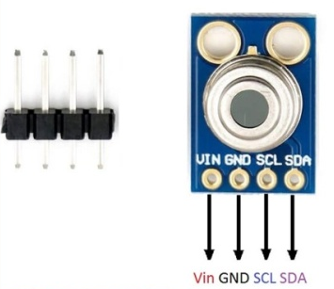
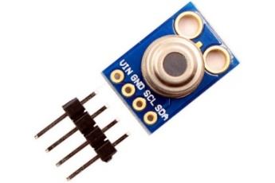

Figure 2. 3 : MLX90614 Sensor Wiring

2.6.1 Key Features of the MLX90614 Sensor
- Non-contact temperature measurement using infrared (IR) technology.
- High accuracy of ±0.2°C in the normal human body temperature range.
- Supports I2C communication (SCL and SDA pins).
- Operates on a voltage range of 3.3V to 5V, making it compatible with various embedded systems.
- Wide temperature range: -40°C to 125°C for objects and -70°C to 380°C for infrared detection, [5].
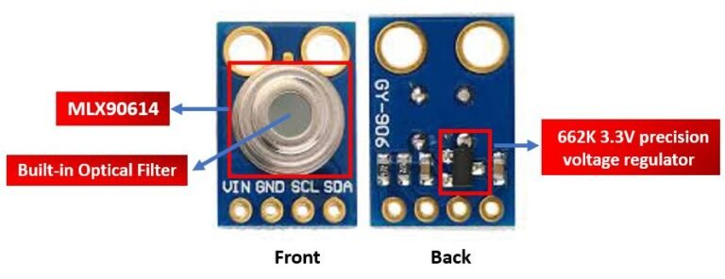
Figure 2. 4 : Detailed Front and Back View of MLX90614 Sensor Module

2.6.2 Enhancing the Smart Vest Functionality Through the Sensor
- Continuous Real-Time Telemetry: Ambient and core body temperature measurements are continuously streamed to the cloud-native web dashboard and mobile application, ensuring constant visibility without requiring any active user initialization.
- AI-Driven Clinical Alerting: Temperature readings are evaluated instantly against clinical safety thresholds. If hyperpyrexia (fever) is detected, the n8n cloud infrastructure triggers immediate emergency notifications to caregivers.
- Long-Term Health Baselines: By constantly appending data points to a secure Google Sheet, the sensor enables the creation of a cont
- Autonomous and Non-Invasive Care: The completely non-contact, passive integration within the fabric ensures a touch-free, hygienic operational workflow that eliminates the discomfort and manual effort associated with traditional clinical thermometers.
Integrating the MLX90614 sensor into the smart vest transforms it into an intelligent edge healthcare companion, providing autonomous, zero-effort thermal monitoring. This integration upgrades the vest from a passive garment into an essential tool for proactive health awareness and early illness detection. As the demand for remote patient monitoring (RPM) solutions grows, this innovation positions the Lifeguard smart vest as a cutting-edge device that enhances clinical mobility, hygiene, and overall patient well-being.
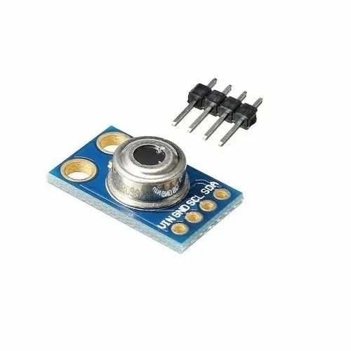
Figure 2. 5 : Infrared Temperature Sensor

2.6.3 Reasons for Choosing ESP32 Dev Module for the Project
During the development of the smart health monitoring vest, selecting the right computing platform was crucial to ensure optimal performance, effective device integration, and ease of programming. After evaluating several options, we found the ESP32 Dev Module to be the most suitable choice for this project. This decision is based on several engineering advantages—such as its dual-core architecture, integrated wireless capabilities, and ultra-low power consumption—that make it superior to alternatives such as the standard Arduino Uno and single-board computers like the Raspberry Pi 4 Model B for wearable biomedical applications.
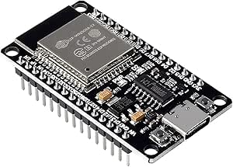

Figure 2.6 : ESP32 Dev Module Board

2.6.4 High Performance in an Ultra-Compact Size

The ESP32 features a 32-bit Xtensa dual-core LX6 microprocessor clocked at up to 240 MHz. This architecture provides exceptional processing power optimized for embedded environments, allowing the Lifeguard system to execute highly responsive edge-computing algorithms—such as real-time multi-sensor calibration and continuous 3D vector acceleration mathematics for fall detection—while maintaining an incredibly small hardware footprint essential for a comfortable wearable vest.

2.6.5 RTOS and Lightweight Firmware Architecture
- Real-Time Determinism: Unlike the Raspberry Pi, which relies on a heavy, resource-intensive operating system (like Raspberry Pi OS or Ubuntu Linux) that introduces substantial boot latencies and multi-tasking overheads, the ESP32 operates on lightweight firmware and natively supports FreeRTOS (Real-Time Operating System).
- Reliability in Critical Care: This bare-metal and real-time execution capability ensures deterministic task scheduling, meaning critical health monitoring scripts and emergency alert triggers are executed instantly without the risk of OS-level crashes, freeze-ups, or unprompted background updates.
- Superiority Over Basic Microcontrollers: While standard microcontrollers like the Arduino Uno lack multi-threading and wireless stacks altogether, the ESP32 effectively bridges the gap by running dual-core operational logic without the power and space penalizations of a full desktop OS.

2.6.6 Versatile Programming and Comprehensive Connectivity
- Robust Framework Support: The ESP32 supports efficient programming in C/C++ using the optimized Arduino framework and ESP-IDF, allowing developers to implement highly optimized, low-level memory and hardware control..
- Integrated Wireless Transceivers: It features onboard 2.4 GHz Wi-Fi and Bluetooth Low Energy (BLE) on a single chip. This allows the vest to seamlessly connect to the local network to stream JSON payloads to the n8n cloud server without requiring any external hardware shields or dongles.
- Advanced Hardware Bus Architecture: Unlike standard boards that degrade in performance when handling multiple peripherals, the ESP32 features dedicated hardware I2C and SPI buses, facilitating flawless, high-speed simultaneous data polling from the complete medical sensor array (MAX30105, MPU6050, MLX90614, and AD8232).

2.6.7 Cost-Effective and Power-Efficient Solution
- Economic Advantage: Compared to single-board computers like the Raspberry Pi 4 or high-end AI processing nodes like the NVIDIA Jetson Nano, the ESP32 provides a highly affordable yet specialized IoT platform. This dramatic cost reduction makes the Lifeguard system a commercially viable product for mass medical deployment.
- The Efficiency Balance: While platforms like the Jetson Nano offer advanced neural network processing at a steep financial and power premium, the ESP32 perfectly optimizes the engineering trade-off. It offloads heavy AI tasks to cloud infrastructures (such as the Gemini AI model via n8n workflows) while locally running energy-efficient edge computations, allowing the entire vest to run reliably on a small, lightweight Li-Po battery.

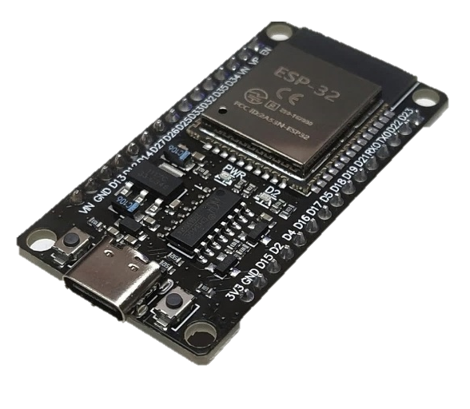
Figure 2. 7 ESP32 Dev Module Kit

2.7 Comparison between Raspberry Pi and Arduino
There are two revolutionary electronic components that have changed the world's view of microcomputers and electronic control sciences: the Raspberry Pi and the Arduino Uno. As shown in Table 2, the Raspberry Pi is a computer made from ARM SoC chips. The Arduino Uno is a microcontroller board containing an Atmega328, designed for electronic control applications only, and programmed in the Arduino C language or traditional C language, [8].

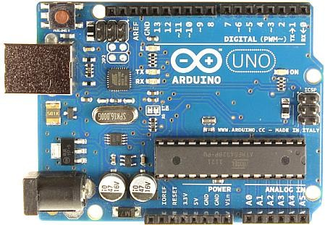
Figure 2. 8 : Arduino UNO Microcontroller Board

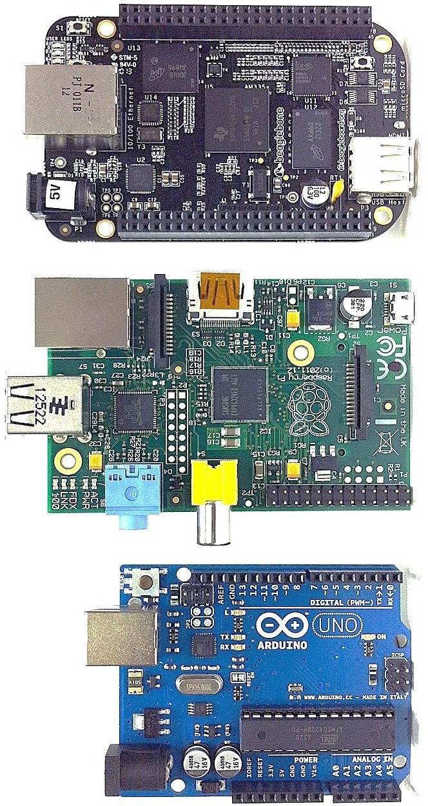

Figure 2. 9 : Raspberry Pi 4

Table 2 : The difference between All Types of Arduino and Raspberry Pi Boards
Feature | Arduino Uno | Arduino Mega 2560 | Arduino Nano | Arduino Leonardo | Arduino Due
Price | $24 | $30 | $22 | $25 | $40
Version | R3 | Rev3 | 3.0 | Rev3 | Rev3
SoC Chip | ATmega328P | ATmega2560 | ATmega328P | ATmega32u4 | ARM Cortex-M3
Speed | 16 MHz | 16 MHz | 16 MHz | 16 MHz | 84 MHz
RAM | 2 KB | 8 KB | 2 KB | 2.5 KB | 96 KB
ROM | 32 KB Flash | 256 KB Flash | 32 KB Flash | 32 KB Flash | 512 KB Flash
Voltage Supply | 5–12 V | 5–12 V | 5 V | 5 V | 7–12 V
High Quality Video | No | No | No | No | No
Current Consumption | ~42 mA | ~70 mA | ~19 mA | ~30 mA | ~100 mA
I²C Ports | 1 | 1 | 1 | 1 | 2
SPI Ports | 1 | 1 | 1 | 1 | 1
UART Ports | 1 | 4 | 1 | 1 | 4
USB Ports | No | No | No | 1 | 1
Ethernet Port | No | No | No | No | No
Audio Port | No | No | No | No | No
Supported Languages | Arduino C | Arduino C | Arduino C | Arduino C | Arduino C
Display Output | No | No | No | No | No
PWM Ports | 6 | 15 | 6 | 7 | 12

Feature | Arduino MKR Series | Arduino Pro Mini | Raspberry Pi 1 A/B | Raspberry Pi 2 B | Raspberry Pi 3 B/B+
Price | $35+ | $20 | $25–35 | $35 | $35–40
Version | Various | 3.3V/5V | Model A/B | Model B | Model B/B+
SoC Chip | SAMD21 Cortex-M0+ | ATmega328 | ARM11 | Cortex-A7 | Cortex-A53
Speed | 48 MHz | 8/16 MHz | 700 MHz | 900 MHz | 1.2–1.4 GHz
RAM | 32 KB | 2 KB | 256–512 MB | 1 GB | 1 GB
ROM | 256 KB Flash | 32 KB Flash | SD Card | microSD | microSD
Voltage Supply | 3.3 V | 3.3/5 V | 5 V | 5 V | 5 V
High Quality Video | No | No | Yes | Yes | Yes
Current Consumption | ~50 mA | ~15 mA | 300–500 mA | 600 mA | 700–900 mA
I²C Ports | 1 | 1 | 1 | 1 | 1
SPI Ports | 1 | 1 | 1 | 1 | 1
UART Ports | 1 | 1 | 1 | 1 | 1
USB Ports | 1 | No | 1–2 | 4 | 4
Ethernet Port | Optional | No | Model B: Yes | Yes | Yes
Audio Port | No | No | 3.5mm/HDMI | 3.5mm/HDMI | 3.5mm/HDMI
Supported Languages | Arduino C | Arduino C | Linux-based | Linux-based | Linux-based
Display Output | No | No | HDMI | HDMI | HDMI
PWM Ports | 12 | 6 | GPIO based | GPIO based | GPIO based

Feature | Raspberry Pi 4 B | Raspberry Pi Zero/Zero W | Raspberry Pi 400 | Raspberry Pi 5
Price | $35–75 | $10–15 | $70–100 | $60–90
Version | Model B | Zero/W | 400 | Model B
SoC Chip | Cortex-A72 | ARM11 | Cortex-A72 | Cortex-A76/A78 combo
Speed | 1.5 GHz | 1 GHz | 1.8 GHz | 2.4+ GHz
RAM | 2/4/8 GB | 512 MB | 4 GB | 4/8 GB
ROM | microSD | microSD | microSD | microSD
Voltage Supply | 5 V (USB-C) | 5 V | 5 V (USB-C) | 5 V (USB-C)
High Quality Video | Yes (4K) | Yes | Yes (4K) | Yes (dual 4K)
Current Consumption | 600–1000 mA | 150–200 mA | 600–800 mA | TBD
I²C Ports | 1 | 1 | 1 | 1
SPI Ports | 1 | 1 | 1 | 1
UART Ports | 1 | 1 | 1 | 1
USB Ports | 4 (2×USB3) | 1 micro-USB | 3 | 4
Ethernet Port | Yes | Zero W: Yes | Yes | Yes
Audio Port | 3.5mm/HDMI | Mini HDMI | 3.5mm/HDMI | 3.5mm/HDMI
Supported Languages | Linux-based | Linux-based | Linux-based | Linux-based
Display Output | 2× micro-HDMI | Mini HDMI | 2× micro-HDMI | 2× micro-HDMI
PWM Ports | GPIO based | GPIO based | GPIO header | GPIO based

2.8 ESP Microcontroller

2.8.1 Definition
ESP (Espressif Systems Platform) microcontrollers are low-cost, low-power system-on-chip (SoC) microcontrollers with integrated Wi-Fi and Bluetooth capabilities, primarily used for Internet of Things (IoT) applications. The most popular series includes ESP8266 and ESP32.

2.8.2 How It Works
ESP microcontrollers operate by connecting sensors and devices to a microcontroller that communicates wirelessly via Wi-Fi or Bluetooth. They are programmable using environments such as Arduino IDE or MicroPython, making them ideal for rapid prototyping of IoT solutions.

2.8.3 Types of ESP Microcontrollers
- ESP8266
- ESP32
- ESP32-S2
- ESP32-C3

2.8.4 Comparison Between Types of ESP Microcontrollers

Table 3 : Comparison Between Types of ESP Microcontrollers
Feature | ESP8266 | ESP32 | ESP32-S2 | ESP32-C3
Processor | Single-core 80 MHz | Dual-core 240 MHz | Single-core 240 MHz | Single-core 160 MHz
Wi-Fi | 2.4 GHz | 2.4 GHz | 2.4 GHz | 2.4 GHz
Bluetooth | No | BT 4.2 + BLE | No | BT 5 + BLE
GPIO Pins | ~17 | ~34 | ~43 | ~22
ADC Channels | 1 (10-bit) | 12 (12-bit) | 20 (12-bit) | 6 (12-bit)
Power Efficiency | Medium | Low | High | Very High
Security Features | Basic | AES, RSA, Secure Boot | USB OTG, AES | Secure Boot, Flash Encryption
Price Range | Very Low (~2-3 USD) | Low (~4-7 USD) | Mid (~5-8 USD) | Low (~3-5 USD)
Use Cases | Basic IoT | Advanced IoT, AIoT | USB devices, secure IoT | Secure and low-power IoT

2.8.5 Why ESP is Popular in IoT Projects
- Built-in Wi-Fi: No need for external modules.
- Low Power Consumption: Suitable for battery-powered systems.
- Open Source Support: Supported by large communities and libraries.
- Affordable: Highly cost-effective for prototyping and production.

2.9 Central Processing Unit: ESP Microcontroller Series

2.9.1 Historical Evolution and Architectural Rationale
The core operational paradigm of the LifeGuard Smart Health Monitoring System revolves around dependable, real-time edge computing. In wearable biomedical instrumentation, selecting the primary processing unit requires a delicate balance between computational throughput, electrical power constraints, physical dimensions, and wireless communication capabilities. Traditional architectures frequently utilize single-board computers (SBCs) like the Raspberry Pi or basic 8-bit microcontrollers like the Arduino UNO. However, SBCs introduce prohibitive power demands and thermal management complications, while 8-bit microcontrollers lack the processing power, multi-threading capabilities, and native networking stacks required for continuous cloud telemetry.
To resolve these architectural challenges, this project implements the ESP32 Dev Module as the centralized processing node. Developed by Espressif Systems, the ESP series represents a significant leap from the legacy ESP8266 platform. While the ESP8266 introduced low-cost Wi-Fi connectivity to the masses, its single-core architecture, lack of Bluetooth peripherals, and restrictive analog-to-digital converter (ADC) channels made it insufficient for multi-sensor biomedical devices. The ESP32 overcomes these limitations by integrating a high-frequency microprocessor with native Wi-Fi and dual-mode Bluetooth (Classic and BLE) subsystems on a single silicon die. Operating on a bare-metal embedded framework (C++ via Arduino IDE) or Real-Time Operating Systems (RTOS), the ESP32 handles low-latency multi-sensor fusion while preserving the battery life of the wearable vest.

2.9.2 Microarchitectural Specifications and Hardware Blocks
The ESP32 Dev Module features an advanced internal silicon architecture designed to accommodate intensive signal processing workloads and simultaneous data execution streams:
- The Microprocessor Core: The chip is powered by a 32-bit Xtensa dual-core Tensilica LX6 microprocessor, capable of operating at an adjustable clock frequency ranging from 80 MHz up to 240 MHz. This asymmetric or symmetric dual-core topology allows for strict hardware-level task isolation. In the LifeGuard framework, Core 0 is dedicated to running the network stacks, executing Wi-Fi handshakes, managing the TCP/IP framework, and maintaining secure MQTT/HTTPS cloud connections. Concurrently, Core 1 operates as a deterministic execution engine, managing real-time sensor polling, digital filtering of ECG signals, and fall-detection vector calculations.
- Memory Subsystem Layout: To support multi-threaded applications and prevent stack overflow during high-frequency sampling, the ESP32 contains an internal memory layout consisting of 520 KB of Static RAM (SRAM) split into instruction and data buses, alongside 448 KB of read-only memory (ROM) for core booting routines. The development module further integrates 4 MB of external Serial Peripheral Interface (SPI) Flash memory to store the compiled application firmware, local data logs, and network credentials securely.
- On-Chip Peripheral Controllers: The ESP32 provides a dense matrix of input/output interfaces essential for medical sensor arrays:
  - Hardware I^2C Interfaces: Dedicated hardware I^2C controllers with programmable clock speeds are used to interface with the MLX90614 body temperature sensor, the MPU6050 inertial measurement unit, and the MAX30105 pulse oximeter via a shared multi-drop bus topology.
  - Successive Approximation Register (SAR) ADCs: Features two 12-bit resolution SAR analog-to-digital converters distributed across 18 channels. These channels sample the high-frequency analog outputs of the AD8232 ECG sensor with precise voltage resolution.
  - Hardware Timers: Built-in 64-bit hardware timers are configured to trigger precise interrupt service routines (ISRs) for strictly timed biological signal sampling.

2.9.3 Comprehensive Comparative Evaluation of the ESP Family
The Espressif product ecosystem has evolved across several distinct chip generations, each engineered to address specific IoT and edge-computing profiles. Understanding these distinctions underscores why the standard ESP32 remains the optimal choice for the LifeGuard platform:
Architectural Metric | ESP8266 Generation | ESP32 (Standard) | ESP32-S Series (e.g., S3) | ESP32-C Series (e.g., C3)
CPU Architecture | 32-bit Tensilica L106 | 32-bit Tensilica LX6 | 32-bit Tensilica LX7 | 32-bit RISC-V
Core Count | Single-Core | Dual-Core (Symmetric) | Dual-Core / Single-Core | Single-Core
Max Clock Speed | 80 MHz to 160 MHz | 240 MHz | 240 MHz | 160 MHz
Wireless Protocols | Wi-Fi 2.4 GHz only | Wi-Fi 2.4 GHz + Bluetooth v4.2 & BLE | Wi-Fi 2.4 GHz + Bluetooth 5.0 (BLE) | Wi-Fi 2.4 GHz + Bluetooth 5.0 (BLE)
Hardware Security | Basic WEP/WPA | Secure Boot, Flash Encryption, AES/SHA/RSA | Hardware AES/SHA, RSA, ECC, RNG, Secure Boot | Secure Boot, Flash Encryption, Digital Signature
Primary Use-Case | Low-cost Wi-Fi bridges | Complex Sensor Fusion & Smart Wearables | Machine Learning Edge & Camera Processing | Ultra-low Power Smart Home Nodes
- ESP8266: Represented the initial milestone in low-cost Wi-Fi integration. However, its single-core constraints, lack of integrated Bluetooth/BLE modules, and limited GPIO breakout render it obsolete for multi-sensor biomedical vests.
- ESP32 (Selected): Provides the specific balance of dual-core multitasking, high SRAM capacity, and extensive analog-to-digital peripheral channels needed to handle simultaneous ECG, PPG, temperature, and motion tracking.
- ESP32-S & C Series: The C-series introduces highly efficient RISC-V designs but scales down total processing performance. The S-series introduces specialized vector extensions for machine learning and native USB interfaces, which exceed the current operational envelope of this telemetry vest.

2.9.4 Advanced Power Management and Telemetry Optimization
Because the LifeGuard system is integrated into a portable vest powered by a Lithium-Polymer (Li-Po) battery, power consumption is a key design consideration. The ESP32 addresses this via an integrated Power Management Unit (PMU) that supports five distinct operational power modes:
- Active Mode: All processing cores, radio peripherals (Wi-Fi/Bluetooth), and internal clocks run at full capacity. This mode is active during data transmission or emergency fall-detection events, with current consumption ranging from 160 mA to 260 mA depending on radio transmission power.
- Modem-Sleep Mode: The CPU remains fully active at 240 MHz, but the Wi-Fi and Bluetooth baseband radios are turned off. This reduces current draw to approximately 20 mA–30 mA, allowing the system to filter sensor data while preserving power between transmission intervals.
- Light-Sleep Mode: The internal CPU cores are clock-gated, and the digital peripherals and radio modules are suspended. The internal state is preserved in RAM, and the chip draws less than 1 mA. It can wake up instantaneously via external GPIO interrupts (e.g., when the MPU6050 detects sudden movement thresholds).
- Deep-Sleep Mode: The CPU, digital peripherals, and RAM are completely powered off. Only the Ultra-Low-Power (ULP) co-processor and the Real-Time Clock (RTC) memory remain active, reducing current consumption to around $10\,\mu\text{A}$ to $150\,\mu\text{A}$. The system can be programmed to wake up at fixed intervals to sample temperature or pulse data, dramatically extending overall battery life.
- Hibernation Mode: All internal systems are powered off except for a single RTC timer on the chip, dropping consumption to less than

2.9.5 Pinout Configuration, GPIO Matrix, and Signal Mapping
The physical implementation of the ESP32 Dev Module within the wearable shirt requires strict pin mapping to prevent hardware pin sharing conflicts and data corruption. The ESP32 utilizes a flexible internal GPIO matrix, allowing internal peripheral signals to be mapped to almost any physical pin. For the LifeGuard system, the external connections are mapped explicitly as follows:
- I2C Bus Configuration (SDA and SCL): The primary hardware $I^2C$ bus is mapped to GPIO 21 (SDA) and GPIO 22 (SCL). These pins are pulled up to resistors to maintain signal integrity at 400 kHz Fast-Mode. This bus sequentially queries the internal registers of the MPU6050, MAX30105, and MLX90614 sensors.
- Analog-to-Digital Ingestion (AD8232 ECG): The analog output pin of the AD8232 ECG setup is mapped to GPIO 34, which is linked internally to SAR ADC1, Channel 6. Because GPIO 34 is an input-only pin on the ESP32, it provides excellent isolation from digital switching noise. The lead-off detection pins (Output Minus and Output Plus) are mapped to digital input pins GPIO 25 and GPIO 26 to monitor electrode detachment in real time.
- Status Indicators and Emergency Triggers: GPIO 2 is tied to the on-board LED for visual debugging of network connectivity states, while GPIO 4 is configured as an output pin to trigger an external active buzzer for immediate audible alerts during acute patient distress or critical fall detection.

CHAPTER THREE LITERATURE REVIEW

A. IoT-Driven Remote Patient Monitoring Architecture
The paradigm of Remote Patient Monitoring (RPM) has experienced a significant shift toward edge-computed, low-power architectural configurations. Central to this transition is the utilization of highly integrated microcontrollers capable of simultaneous multi-sensor polling and wireless data transmission [2], [3], [10]. Several frameworks utilize the ESP32 microcontroller as an edge coordinator due to its dual-core processing capabilities and native Wi-Fi/Bluetooth stacks, which allow for the isolation of critical sensor read cycles from communication tasks [5], [6], [12], [22]. To sustain these edge operations in long-term ambulatory scenarios, dynamic power management and battery optimization frameworks are heavily critical for ESP32-based wearable configurations [49]. This edge-centric allocation ensures deterministic data sampling intervals necessary for physiological signal telemetry [14]. Moreover, integrating continuous monitoring solutions within localized environments mitigates the burden on physical healthcare infrastructure, creating a resilient layer of home-based patient oversight [20].

B. Wearable Biosensors and Physiological Signal Conditioning
Accurate extraction of continuous vital signs requires a synergistic integration of optoelectronic, thermodynamic, and bioelectric transducers embedded into smart garments. Photoplethysmography (PPG) using integrated modules like the MAX30105 sequence remains the benchmark for non-invasive heart rate and peripheral oxygen saturation $\left({\text{SpO}}_{}\right)$ monitoring [9]. However, raw PPG signals are notoriously susceptible to motion artifacts, necessitating adaptive digital filtering directly at the firmware or edge node level before packet serialization [32], [44].
For bioelectric evaluation, single-lead electrocardiogram (ECG) modules, such as the AD8232, capture the fundamental depolarization and repolarization vectors of the myocardium [1]. Recent advancements focus on shifting away from conventional silver/silver-chloride $\left(\text{Ag}\text{/}\text{AgCl}\right)$ gel electrodes toward conductive textile sensors woven directly into the fabric matrices of wearable garments, minimizing skin irritation while maintaining high signal-to-noise ratios [31], [34]. Beyond signal fidelity, the physical integration must account for the thermal comfort and ergonomic design of smart textile vests housing embedded electronics to ensure prolonged patient compliance [52]. Furthermore, localized thermodynamic evaluation via non-contact infrared sensors like the MLX90614 provides clinical-grade core body temperature telemetry when situated in fixed-proximity anatomical zones, such as the inner neck collar assembly, [33].

C. Kinematic Analysis and Spatial Vector Fall Detection
The integration of micro-electromechanical systems (MEMS) inertial measurement units (IMUs), predominantly the MPU6050, has standardized the capture of human kinematic displacement [16], [17]. Fall detection methodology typically relies on monitoring tri-axial linear acceleration and angular velocity to derive a real-time Net Acceleration Vector$\left(A_{net}\right):$
$$A_{net}=\sqrt{A_{x}^{2}+A_{y}^{2}+A_{z}^{2}}$$
When $A_{net}$ crosses a high-g impact threshold followed immediately by a prolonged period of relative immobility, a fall condition is inferred [19], [21]. However, raw IMU signals frequently suffer from high-frequency sensor noise and orientation drift, requiring the implementation of Kalman filtering and drift compensation algorithms to maintain kinematic tracking accuracy [50]. To minimize false positives generated by daily living activities (ADLs), recent research leverages machine learning classifiers, such as One-Class Support Vector Machines (SVM) running on adjacent cloud systems or advanced edge nodes [15]. The spatial placement of the sensor framework remains a critical vector; positioning the IMU adjacent to the thoracic region or the body’s center of gravity drastically stabilizes vector calculations compared to peripheral extremity placement [18], [35].

D. Cloud Pipelines, Low-Code Workflows, and Intelligent Alerting
The progression from localized telemetry to distributed cloud infrastructures demands reliable, lightweight data ingestion pathways. Standard methodologies utilize HTTP POST requests to stream structured JSON payloads from edge devices to cloud gateways at high frequencies, [24]. Given the exposure of these cloud pathways, securing webhook endpoints using lightweight cryptography is essential for safeguarding transmitted telemetry on low-power Internet of Medical Things (IoMT) networks [46]. Low-code orchestration engines, such as n8n and Node-RED, have recently emerged as enterprise-grade alternatives to hardcoded backend microservices, offering deterministic visual node routing, rapid API integration, and reduced maintenance overhead [36], [37]. These platforms excel at orchestrating Large Language Models (LLMs) and processing data streams efficiently [51]. For data persistence, studies have benchmarked the performance of cloud-based spreadsheets, such as Google Sheets, against traditional NoSQL databases for real-time bio-telemetry logging, noting specific tradeoffs in throughput and simplicity [47].
For condition assessment, traditional remote systems have historically relied on crisp logical thresholds or fuzzy rule-based inference models to trigger emergency events, [27]. However, the integration of generative Artificial Intelligence and LLMs represents a new frontier, transforming traditional alerting into contextual Clinical Decision Support Systems (CDSS) capable of synthesizing multi-parametric emergency telemetry into narrative medical overviews [4], [7], [13], [26], [28], [29]. These synchronized automated pipelines route generated alerts through instantaneous chat-bot and instant messaging application endpoints, such as Telegram, for real-time caregiver notification [25], [39], [48]. To optimize user experience on mobile applications, recent literature evaluates the latency profiles of WebSockets versus traditional HTTP GET polling over IoMT cloud networks [54]. Furthermore, modern backend databases optimize queries to pull strictly the final row of telemetry data, avoiding redundant historical parsing during live interactions [30].

E. Next-Generation Paradigms and Future Roadmap
As remote health monitoring architectures mature beyond basic telemetry ingestion, the focus is pivoting toward decentralized intelligence, virtual physical mapping, and psychological parameter tracking. A profound challenge in IoMT deployments is the preservation of strict patient privacy over public networks [11], [23]. Emerging frameworks are exploring Federated Learning (FL) architectures, which enable localized edge nodes to collaboratively train diagnostic models without transferring raw, identifiable biosensor data to a centralized cloud server [41]. To further decentralize intelligence, modern frameworks explore TinyML implementations for real-time ECG anomaly detection directly on resource-constrained edge microcontrollers, reducing the reliance on constant cloud connectivity [53].
Simultaneously, the concept of the "Digital Twin" in personalized medicine is gaining traction, wherein continuous multi-sensor streams are mapped onto an evolving, virtual physiological profile to execute predictive simulation modeling for long-term health anomalies [42]. Finally, advanced research is investigating the amalgamation of autonomic nervous system indicators—derived from continuous cardiovascular and galvanic skin responses—to map physical telemetry directly to emotional state and cognitive stress profiles, creating a holistic diagnostic and automated assistant environment [45], [55].

CHAPTER FOUR HARDWARE

4.1 Overview
This chapter presents a comprehensive description of the hardware design and implementation of the proposed Smart Health Monitor system. The system is designed as an Internet of Things (IoT)-based healthcare solution that integrates multiple biomedical sensors, a processing unit, and communication modules to enable real-time health monitoring.
The hardware architecture focuses on collecting vital physiological parameters from the user, processing these signals, and transmitting them to a mobile application and cloud platform for further analysis. The design emphasizes accuracy, reliability, portability, and low power consumption.
The main components of the system include biomedical sensors such as heart rate, body temperature, blood oxygen (SpO2), and motion sensors, in addition to a microcontroller unit responsible for data acquisition and communication. These components work together to form a complete and intelligent health monitoring system.

4.2 System Architecture
The Smart Health Monitor system is composed of several interconnected hardware modules that operate in a sequential and integrated manner.
The system begins with the data acquisition stage, where different sensors collect real-time physiological signals from the user. These signals are then transmitted to the processing unit, which performs initial filtering and preparation of the data.
After processing, the data is transmitted wirelessly to a mobile application using built-in communication technologies such as Wi-Fi or Bluetooth. Simultaneously, the data can be uploaded to a cloud server for storage, remote monitoring, and advanced analysis using artificial intelligence techniques.
The system architecture can be summarized as follows:
- Sensors → Data Acquisition
- Microcontroller → Data Processing
- Communication Module → Data Transmission
- Mobile Application / Cloud → Data Visualization and Analysis
This architecture ensures real-time monitoring, scalability, and ease of integration with modern healthcare systems.
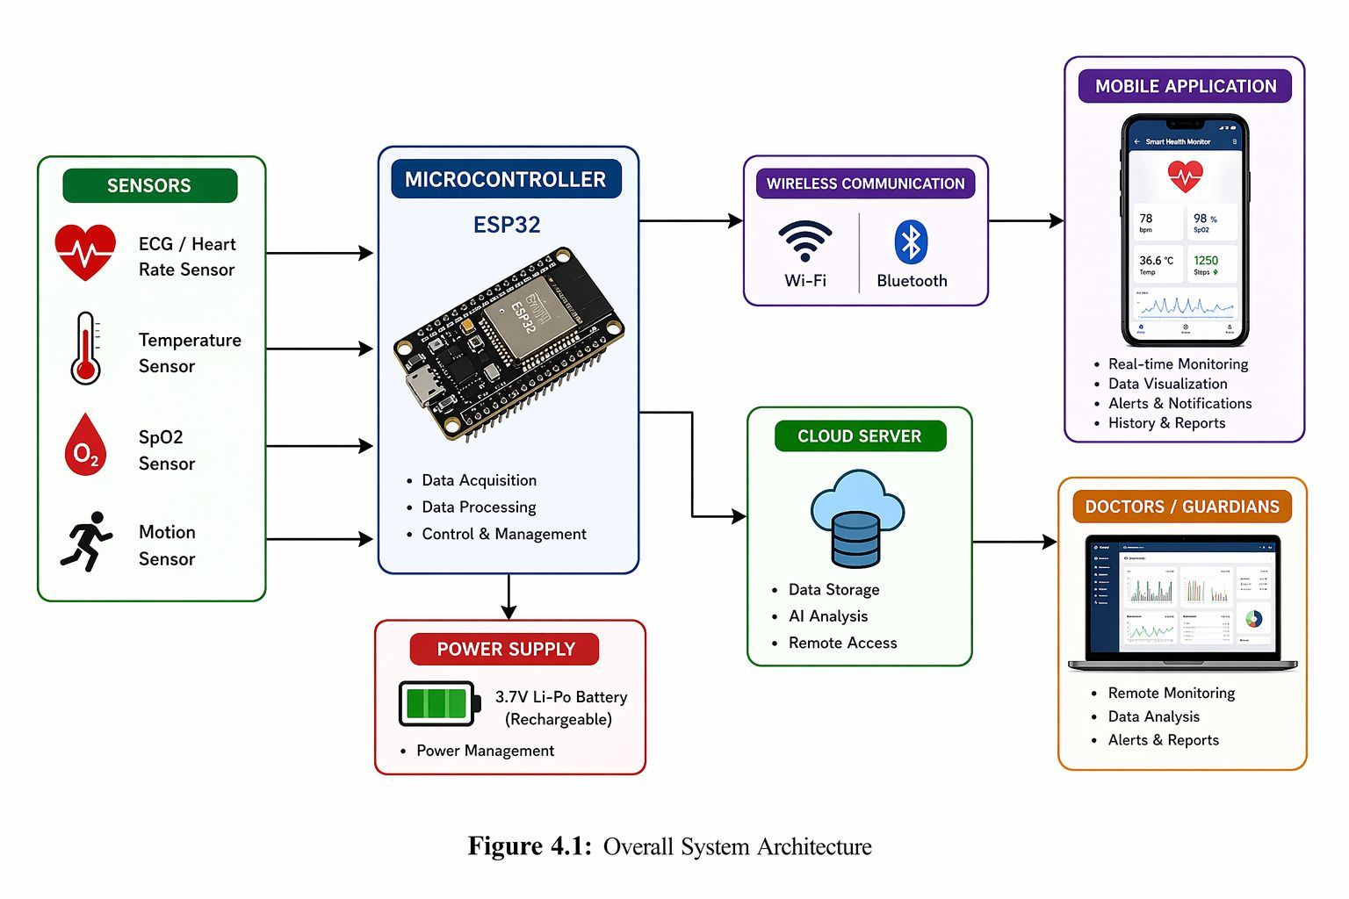

4.3 Hardware Components of the System
The Smart Health Monitor hardware consists of several essential components that collectively ensure proper functionality and accurate data measurement. These components are carefully selected to achieve a balance between performance, cost, and power efficiency.
The main hardware components include:
- Microcontroller Unit (Main Processing Unit)
- Heart Rate and ECG Sensor
- Temperature Sensor
- SpO2 Sensor
- Motion Sensor
- Communication Module (Wi-Fi / Bluetooth)
- Power Supply Unit
- Connecting Elements (Wires and Breadboard)
Each component plays a specific role in the system and contributes to the overall performance and reliability.

4.4 Sensors
Sensors represent the core of the Smart Health Monitor system, as they are responsible for collecting real-time physiological data from the user. The integration of multiple sensors allows the system to provide a comprehensive overview of the user's health condition.
4.4.1 Heart Rate and ECG Sensor
The heart rate and ECG sensor is used to monitor the electrical activity of the heart and measure the user's pulse in real time. This sensor plays a critical role in detecting abnormalities such as irregular heartbeats and potential cardiovascular risks.
The sensor works by detecting electrical signals generated by the heart and converting them into digital data that can be processed by the microcontroller.
Figure 4. 2 : Electrocardiogram sensor
Key Features:
- Real-time heart activity monitoring
- High accuracy in pulse detection
- Early detection of heart-related issues
- Continuous data acquisition
This sensor is essential for providing critical health insights and enhancing the medical value of the system.

4.4.2 Body Temperature Sensor
The temperature sensor is used to measure the user's body temperature, which is an important indicator of overall health. Abnormal temperature readings may indicate infections or other medical conditions.
The sensor operates by detecting thermal energy and converting it into an electrical signal that is processed by the microcontroller.
Figure 4. 3 : Temperature sensor
Key Features:
- Accurate temperature measurement
- Fast response time
- Continuous monitoring capability
- Easy integration with microcontroller systems
This sensor enhances the system’s ability to detect early signs of illness.
4.4.3 SpO2 Sensor (Blood Oxygen Level)
The SpO2 sensor measures the oxygen saturation level in the blood, which is a crucial parameter for assessing respiratory efficiency.
It works using optical techniques by emitting light through the skin and measuring the amount absorbed by oxygenated and deoxygenated blood.
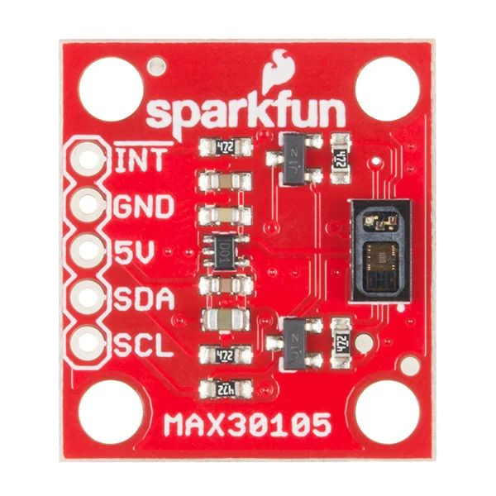
Figure 4. 4 : SpO2 sensor
Key Features:
- Non-invasive measurement
- High sensitivity and accuracy
- Real-time oxygen level tracking
- Essential for respiratory monitoring
This sensor is particularly important for patients with respiratory or cardiac conditions.
4.4.4 Motion Sensor
The motion sensor is used to detect user movement and physical activity. It helps in tracking user behavior and can be used for additional health analysis such as activity level and fall detection.
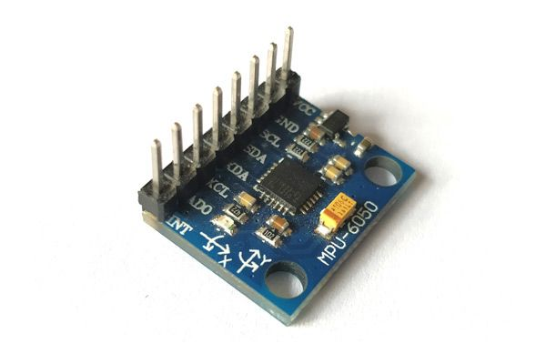
Figure 4. 5 : motion sensor
Key Features:
- Detects motion and presence
- Low power consumption
- Enhances system interactivity
- Useful for activity monitoring

4.5 Microcontroller Unit (Processing Unit)
The microcontroller acts as the central processing unit of the Smart Health Monitor system. It is responsible for collecting data from all sensors, processing it, and transmitting it to external devices.
The selected microcontroller provides built-in communication capabilities such as Wi-Fi and Bluetooth, making it ideal for IoT-based applications.
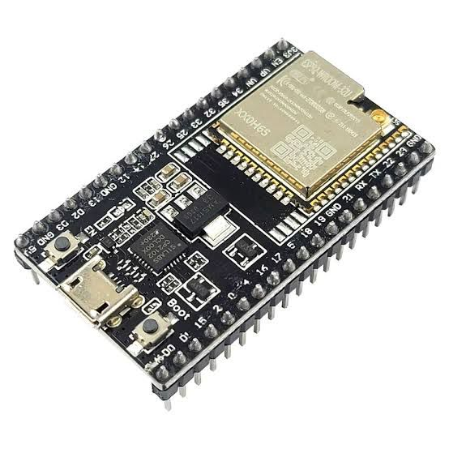
Figure 4. 6 : Microcontroller
Main Functions:
- Reading sensor data
- Processing and filtering signals
- Managing communication protocols
- Controlling system operations

Advantages:
- Low power consumption
- Compact size
- High processing efficiency
- Integrated wireless communication
The microcontroller ensures seamless integration between all system components.

4.6 Communication Module
Communication is a key part of the system, enabling data transfer between the hardware device and external platforms such as mobile applications and cloud servers.
The system uses wireless communication technologies such as:
- Wi-Fi: For cloud connectivity and remote monitoring
- Bluetooth: For short-range communication with mobile devices
Features:
- Real-time data transmission
- Secure communication
- Low latency
- Compatibility with mobile applications
This module allows users and doctors to access health data from anywhere.

4.7 Power Supply System
The power supply unit provides the necessary electrical energy to operate all hardware components.
The system is designed to be energy-efficient, ensuring long operation time and reliability.
Key Characteristics:
- Stable voltage output
- Protection against overcurrent
- Suitable for portable use
- Efficient power consumption
Power management is essential to ensure continuous system performance without interruptions.

4.8 Hardware Integration
The integration of all hardware components is a critical step in building the Smart Health Monitor system. All sensors are connected to the microcontroller using appropriate interfacing techniques.
The microcontroller collects data from the sensors through analog or digital pins, processes it, and transmits it via the communication module.
The system is designed in a modular way, allowing easy expansion and addition of new sensors or features in the future.
Proper wiring, secure connections, and efficient layout design are considered to ensure system stability and performance.

4.9 Summary
In this chapter, the hardware design and implementation of the Smart Health Monitor system were presented in detail. The system integrates multiple biomedical sensors with a microcontroller and communication modules to provide a reliable and efficient health monitoring solution.
The hardware architecture ensures accurate data collection, real-time processing, and seamless communication with external platforms. This design forms the foundation for the software implementation and intelligent analysis discussed in the next chapter.

CHAPTER FIVE SOFTWARE

5.1 ESP32 Dev Module and Code Architecture
This section provides a detailed technical breakdown of the firmware developed for the ESP32 microcontroller powering the Lifeguard Smart Vest. The code is engineered utilizing a Non-blocking Multi-tasking Architecture through the elimination of hardcoded delays (delay()), substituting them with temporal deltas via millis(). This optimizes the dual-core utilization, ensuring that sensor polling, local edge computing, asynchronous web server requests, and remote cloud communication operate concurrently without system latency.
Code:
#include <Wire.h>
#include <WiFi.h>
#include <WebServer.h>
#include <HTTPClient.h>
#include <Adafruit_Sensor.h>
#include <math.h>
#include "MAX30105.h"
#include "heartRate.h"
#include <Adafruit_MLX90614.h>
// --- Configuration ---
const char* ssid = "Vodafone_bahaa_VDSL_E6AA_2.4G";
const char* password = "SSABD5BOB#1QAZ@2WSX@3ed";
const char* n8n_webhook = "https://d2c96ee7.kube-ops.com/webhook-test/sensor-data";
#define THERMISTOR_PIN 34
#define SERIES_RESISTOR 10000
#define NOMINAL_RESISTANCE 10000
#define B_COEFFICIENT 3950
#define ADC_MAX 4095
#define ECG_OUTPUT_PIN 35
#define ECG_LO_PLUS_PIN 32
#define ECG_LO_MINUS_PIN 33
#define MPU_ADDR 0x68
// --- Global Objects ---
WebServer server(80);
MAX30105 particleSensor;
Adafruit_MLX90614 mlx;
// --- Flags ---
bool mpuOK = false;
bool mlxOK = false;
bool maxOK = false;
// --- Vitals Variables ---
float bodyTemp = 0;
float objectTemp = 0;
float ambientTemp = 0;
String motion = "Stable";
int beatAvg = 0;
int approxSpO2 = 0;
long lastBeat = 0;
const byte RATE_SIZE = 4;
byte rates[RATE_SIZE];
byte rateSpot = 0;
int ecgValue = 0;
String ecgStatus = "Normal";
float currentAccX = 0, currentAccY = 0, currentAccZ = 0;
unsigned long lastPostTime = 0;
const long postInterval = 2000;
void handleRoot() {
server.send_P(200, "text/html", INDEX_HTML);
}
void handleData() {
String json = "{";
json += "\"heart_rate\":" + String(beatAvg) + ",";
json += "\"spo2\":" + String(approxSpO2) + ",";
json += "\"temp\":" + String(bodyTemp, 1) + ",";
json += "\"motion\":\"" + motion + "\",";
json += "\"ecg_raw\":" + String(ecgValue) + ",";
json += "\"ecg_status\":\"" + ecgStatus + "\",";
json += "\"mlx_object\":" + String(objectTemp, 1) + ",";
json += "\"mlx_ambient\":" + String(ambientTemp, 1) + ",";
json += "\"mlx_error\":" + String(mlxOK ? "false" : "true") + ",";
json += "\"mpu_error\":" + String(mpuOK ? "false" : "true") + ",";
json += "\"max_error\":" + String(maxOK ? "false" : "true") + ",";
json += "\"ir_raw\":" + String(maxOK ? particleSensor.getIR() : 0);
json += "}";
server.sendHeader("Access-Control-Allow-Origin", "*");
server.send(200, "application/json", json);
}
// ── Setup ────────────────────────────────────────────────────────────────────
void setup() {
Serial.begin(115200);
Wire.begin(21, 22);
Wire.setClock(100000);
Wire.beginTransmission(MPU_ADDR);
Wire.write(0x6B); Wire.write(0);
if(Wire.endTransmission() == 0) mpuOK = true;
pinMode(ECG_LO_PLUS_PIN, INPUT);
pinMode(ECG_LO_MINUS_PIN, INPUT);
WiFi.begin(ssid, password);
Serial.print("Connecting to WiFi");
while (WiFi.status() != WL_CONNECTED) { delay(500); Serial.print("."); }
Serial.println("\nWiFi Connected!");
Serial.print("IP Address: ");
Serial.println(WiFi.localIP());
if (!particleSensor.begin(Wire, I2C_SPEED_STANDARD)) { maxOK = false; }
else {
maxOK = true;
particleSensor.setup(60, 4, 2, 100, 411, 4096);
}
if (!mlx.begin()) { mlxOK = false; } else { mlxOK = true; }
server.on("/", handleRoot);
server.on("/data", handleData);
server.begin();
Serial.println("System Ready.");
}
// ── Loop ─────────────────────────────────────────────────────────────────────
void loop() {
server.handleClient();
// 1. ECG
if ((digitalRead(ECG_LO_PLUS_PIN) == 1) || (digitalRead(ECG_LO_MINUS_PIN) == 1)) {
ecgValue = 0;
ecgStatus = "Leads Disconnected";
} else {
ecgValue = analogRead(ECG_OUTPUT_PIN);
ecgStatus = "Normal";
}
// 2. MAX30105
if (maxOK) {
long irValue = particleSensor.getIR();
if (irValue > 7000) {
if (checkForBeat(irValue)) {
long delta = millis() - lastBeat;
lastBeat = millis();
float bpm = 60 / (delta / 1000.0);
if (bpm < 255 && bpm > 20) {
rates[rateSpot++] = (byte)bpm;
rateSpot %= RATE_SIZE;
beatAvg = 0;
for (byte x = 0; x < RATE_SIZE; x++) beatAvg += rates[x];
beatAvg /= RATE_SIZE;
}
}
int rawSpO2 = 104 - (17 * ((float)particleSensor.getRed() / irValue));
approxSpO2 = (approxSpO2 == 0) ? rawSpO2 : (approxSpO2 * 0.9) + (rawSpO2 * 0.1);
} else {
beatAvg = 0;
approxSpO2 = 0;
}
}
// 3. TEMPERATURE
static unsigned long lastTempRead = 0;
if (millis() - lastTempRead > 500) {
int analogValue = analogRead(THERMISTOR_PIN);
if (analogValue > 0) {
float resistance = SERIES_RESISTOR / ((ADC_MAX / (float)analogValue) - 1);
float steinhart = log(resistance / NOMINAL_RESISTANCE) / B_COEFFICIENT;
steinhart += 1.0 / (25 + 273.15);
bodyTemp = (1.0 / steinhart) - 273.15;
}
if (mlxOK) {
float newObj = mlx.readObjectTempC();
if (!isnan(newObj)) objectTemp = newObj;
ambientTemp = mlx.readAmbientTempC();
}
lastTempRead = millis();
}
// 4. MOVEMENT
static unsigned long lastMpuRead = 0;
if (mpuOK && millis() - lastMpuRead > 100) {
Wire.beginTransmission(MPU_ADDR);
Wire.write(0x3B); Wire.endTransmission(false);
Wire.requestFrom(MPU_ADDR, 6, true);
if(Wire.available() >= 6) {
int AcX = Wire.read()<<8 | Wire.read();
int AcY = Wire.read()<<8 | Wire.read();
int AcZ = Wire.read()<<8 | Wire.read();
float netAcc = sqrt(sq(AcX/16384.0) + sq(AcY/16384.0) + sq(AcZ/16384.0));
motion = (netAcc > 3.5) ? "FALL DETECTED!" : ((netAcc > 2.0) ? "Moving" : "Stable");
}
lastMpuRead = millis();
}
// 5. POST to n8n
if (millis() - lastPostTime > postInterval) {
if (WiFi.status() == WL_CONNECTED) {
HTTPClient http;
http.begin(n8n_webhook);
http.addHeader("Content-Type", "application/json");
String jsonPayload = "{";
jsonPayload += "\"heart_rate\":" + String(beatAvg) + ",";
jsonPayload += "\"spo2\":" + String(approxSpO2) + ",";
jsonPayload += "\"temp\":" + String(bodyTemp, 1) + ",";
jsonPayload += "\"motion\":\"" + motion + "\",";
jsonPayload += "\"ecg_raw\":" + String(ecgValue) + ",";
jsonPayload += "\"ecg_status\":\"" + ecgStatus + "\",";
jsonPayload += "\"mlx_object\":" + String(objectTemp, 1) + ",";
jsonPayload += "\"mlx_ambient\":" + String(ambientTemp, 1) + ",";
jsonPayload += "\"mlx_error\":" + String(mlxOK ? "false" : "true") + ",";
jsonPayload += "\"mpu_error\":" + String(mpuOK ? "false" : "true") + ",";
jsonPayload += "\"max_error\":" + String(maxOK ? "false" : "true") + ",";
jsonPayload += "\"ir_raw\":" + String(maxOK ? particleSensor.getIR() : 0);
jsonPayload += "}";
http.POST(jsonPayload);
http.end();
}
lastPostTime = millis();
}
}
5.1.1 Library Dependencies and System Configurations
The firmware relies on a modular combination of standard network communication protocols, hardware bus abstraction layers, and specialized biomedical sensor libraries:
- Networking Modules (WiFi.h, WebServer.h, HTTPClient.h): These libraries manage the Wi-Fi stack, establish local network endpoints, handle client requests on Port 80, and handle outgoing secure HTTP network packages.
- Hardware Inter-Integrated Circuit Protocol (Wire.h): Manages low-level synchronous, serial data exchange between the master ESP32 and slave nodes via the dedicated SDA (Pin 21) and SCL (Pin 22) lines.
- Sensor Specific Abstractions (MAX30105.h, heartRate.h, Adafruit_MLX90614.h): Used to isolate and fetch biometric photoplethysmography (PPG) data, apply digital filtering for real-time heart rate calculation, and interpret digitized thermal infrared radiation.The configuration block defines critical network credentials, the public cloud endpoint hosted on n8n, and localized fixed constants. Hardware calibration constants include parameters for the analog negative temperature coefficient (NTC) thermistor, the default raw I2C memory address of the MPU6050 accelerometer (0x68), and precise digital pin routing for the AD8232 single-lead ECG monitor.
5.1.2 Memory Optimization and Local Web User Interface
To preserve the ESP32's static random-access memory (SRAM), the local user dashboard interface is declared as a static constant character array stored directly within the non-volatile flash memory using the PROGMEM keyword:

This HTML page incorporates highly optimized embedded CSS Grid/Flexbox layouts to render a fully responsive dashboard. It utilizes HTML5 Canvas structures to draw dynamic real-time physiological charts and includes automated asynchronous JavaScript polling via the browser's Native Fetch API. The client dashboard queries the ESP32 internal data structure every 45 milliseconds, creating a zero-lag user experience on both local mobile and desktop devices.

5.1.3 Hardware Handshake and Initialization (Setup Function)
Upon system boot, the setup() function performs a hardware initialization sequence:
- Serial Telemetry Initialization: Establishes serial data transmission at a baud rate of 115200 for debugging.
- I2C Bus Configuration: Starts the I2C master driver via Wire.begin(21, 22) and forces the bus clock speed to 100 kHz to ensure long-wire signal integrity and avoid data corruption.
- Direct Register Modification (MPU6050 Awake): To avoid library overhead and maximize execution speed, the code accesses the MPU6050 directly. It initiates a transaction to address 0x68, writes to the Power Management Register (0x6B), and injects a byte value of 0 to wake the integrated circuit from its default power-down sleep state.
- Network Access Point Connection: Initiates connection to the predefined local Wi-Fi router, executing a blocking loop that queries WiFi.status() until a valid local IP address is leased.
- Biomedical Sensor Initialization: The MAX30105 sensor is initialized and tuned using optimal operational parameters: an LED power setting of 60, a sample average of 4, dual-LED configuration (Red + IR), a sampling rate of 100 Hz, an ADC pulse width of 411, and a dynamic range filter of 4096.
5.1.4 Multi-Tasking Edge Processing Logic (loop Function)
The continuous execution block within the loop() function is programmatically segmented into isolated asynchronous tasks managed by software timers. This guarantees deterministic sensor sampling:

I. Cardiac Signal Conditioning (AD8232 ECG)
The code executes a rapid check of digital input pins ECG_LO_PLUS_PIN and ECG_LO_MINUS_PIN to handle Leads-Off Detection. If an electrode loses physical contact with the patient's chest, the internal hardware flags an error, setting ecgStatus to "Leads Disconnected" and overriding the analytical value to zero. When connections are skin-stable, the internal 12-bit analog-to-digital converter (ADC) captures raw millivolt potential via analogRead(ECG_OUTPUT_PIN).

II. Photoplethysmography Processing (MAX30105)
The firmware tracks the raw Infrared intensity value (irValue). When an active finger placement is detected ($irValue > 7000$), the algorithm evaluates incoming pulses via checkForBeat(). It calculates the time delta (delta) using the internal clock (millis()) and translates it into Beats Per Minute (BPM).
- Moving Average Digital Filter: To filter out artifact noise caused by motion, a rolling marray buffer (rates[4]) computes the mean average of the last four filtered pulses, creating a stable output (beatAvg).
- Blood Oxygen Saturation Calibration ($SpO_2$): Computes a dynamic ratio between the raw alternating current (AC) components of the Red and Infrared LED reflections, translating it linearly into an approximate oxygen percentage:



III. Dual Thermal Acquisition (NTC Thermistor & MLX90614)
Every 500 milliseconds, the system updates temperature baselines. It reads the analog NTC voltage drop at Pin 34, computes the instantaneous electrical resistance of the component, and passes the variable into the normalized Steinhart-Hart simplified log equation:



This allows for localized skin temperature calculation. Concurrently, if the I2C diagnostic flag is active, the system issues an explicit request to the MLX90614 embedded digital signal processor to fetch both the remote object temperature (readObjectTempC()) and ambient environment temperature (readAmbientTempC()).

IV. Inertial Navigation and Edge Fall Detection (MPU6050)
Every 100 milliseconds, the ESP32 performs sequential memory address pointing to read raw binary acceleration outputs starting from memory register 0x3B. It applies bitwise shifts to reconstruct 16-bit signed integer values for the three independent vector dimensions (AcX, AcY, AcZ). The firmware then executes an onboard edge computation to determine the absolute resultant mathematical acceleration vector (NetAcc) normalized against gravity:

An embedded logical conditional matrix maps the structural movement state. If NetAcc spikes past the safety threshold of 3.5 g, the state is immediately flagged as a critical accident ("FALL DETECTED!"), which triggers the local visual overlay and updates the cloud payload. Moderate values categorize the patient as "Moving", while static values register as "Stable".

5.1.5 JSON Serialization and Public Cloud Synchronization
Every 2000 milliseconds (postInterval), the system prepares data for transmission. The ESP32 collects all processed local metrics, system states, and raw signals, wrapping them into a single standardized string formatted as a JavaScript Object Notation (JSON) payload:
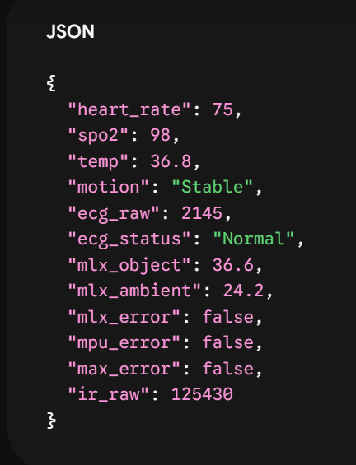

The HTTPClient instance opens an encrypted tunnel to the public cloud URL mapped to the n8n workflow. The data is pushed via a standardized HTTP POST request. The n8n automation engine parses this payload instantly, logging history to Google Sheets, feeding values to the Gemini AI API for clinical summarization, and routing high-priority push notifications to Telegram if anomalies are detected.

5.1.6 System Fault Tolerance and Error Handling
The firmware is engineered with robust defensive coding practices to maximize operational uptime in medical environments:
- System Isolation Architecture: The firmware utilizes specialized health status flags (mpuOK, mlxOK, maxOK). If an individual hardware component suffers a loose connection, wire fault, or structural damage, the system catches the I2C transaction timeout error, sets the respective flag to true, and isolates the fault.
- Continuous Operations: Rather than causing a system crash, freezing the loop, or hanging the processor, the ESP32 bypasses the failed sensor block, transmits an explicit hardware failure flag to the cloud platform, and continues to monitor and process data from all other remaining operational sensors without interruption.

5.2 Cloud Automation and System Workflows (n8n Integration)
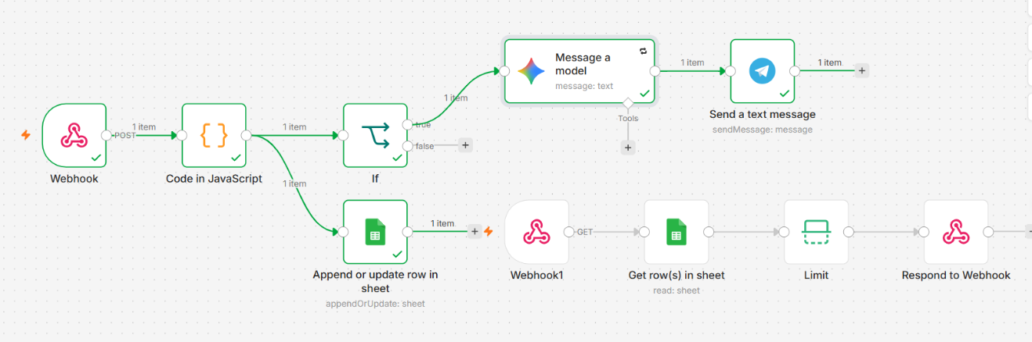
Workflow 2
Workflow 1
The cloud infrastructure of the LifeGuard system is orchestrated using n8n, an advanced, event-driven workflow automation platform. n8n was selected due to its capability to handle real-time data streams with minimal latency, its robust data parsing abilities, and its seamless integration with third-party APIs. To ensure high performance and prevent data congestion, the cloud architecture is divided into two independent asynchronous workflows.

5.2.1 Workflow 1: Data Ingestion, Archiving, and Emergency Triage
This primary workflow is dedicated to receiving continuous telemetry from the ESP32, logging the data, and dispatching instant alerts during critical events.

A. The Entry Point: Webhook Trigger (POST)
The workflow is initiated by a Webhook Node configured to receive HTTP POST requests from the ESP32 every two seconds. To optimize edge device performance, the node is set to respond immediately (Respond Immediately), ensuring the microcontroller's execution loop is never blocked by cloud latency.

B. Algorithmic Data Processing (JavaScript Code Node)
Raw JSON payloads transmitted by edge devices require sanitization and mathematical processing before logging. A custom JavaScript Code Node is implemented to convert raw inputs into float values, handle potential null data (to prevent system crashes), and calculate the Net Acceleration Vector using the formula: $\sqrt{x^2+y^2+z^2}$.

Code Snippet X.1: JavaScript logic for data sanitization and fall detection thresholding.
JavaScript
// Retrieve the incoming JSON payload from the Webhook
const payload = $input.item.json.body || $input.item.json;

// Sanitize sensor data (defaulting to 0 if null)
const bodyTemp = parseFloat(payload.temp_obj) || 0;
const acc_x = parseFloat(payload.acc_x) || 0;
const acc_y = parseFloat(payload.acc_y) || 0;
const acc_z = parseFloat(payload.acc_z) || 0;
const heart_rate = parseInt(payload.heart_rate) || 0;
const spo2 = parseInt(payload.spo2) || 0;
const ecg_raw = parseInt(payload.ecg_raw) || 0;
const ecg_status = payload.ecg_status || "Unknown";

// Calculate Net Acceleration Vector
const netAcc = Math.sqrt((acc_x * acc_x) + (acc_y * acc_y) + (acc_z * acc_z));

// Initialize states
let motion_state = "Stable";
let is_emergency = false;

// Apply medical and physical thresholds
if (netAcc > 25.0 || heart_rate > 120 || (heart_rate < 40 && heart_rate > 0) || spo2 < 90) {
motion_state = (netAcc > 25.0) ? "FALL DETECTED!" : "Critical Vitals";
is_emergency = true;
} else if (netAcc > 16.0) {
motion_state = "Abnormal Shaking";
} else if (netAcc >= 7.5 && netAcc <= 12.5) {
motion_state = "Stable";
} else {
motion_state = "Moving";
}

// Forward the processed payload
return {
json: {
timestamp: new Date().toISOString(),
temperature: bodyTemp.toFixed(1),
heart_rate: heart_rate,
spo2: spo2,
ecg_raw: ecg_raw,
ecg_status: ecg_status,
net_acceleration: parseFloat(netAcc.toFixed(2)),
motion_state: motion_state,
is_emergency: is_emergency
}
};

C. Historical Archiving (Google Sheets)
The sanitized data is systematically routed to a Google Sheets Node (configured to 'Append Row'). This acts as a highly accessible Electronic Health Record (EHR), allowing doctors to review historical patient data.

D. AI-Assisted Triage and Caregiver Notification
An IF Node continuously evaluates the is_emergency boolean flag. If True, the workflow triggers the emergency sequence:
- Gemini AI Node: The critical vital signs are passed to a Large Language Model instructed through specific Prompt Engineering to act as a triage assistant.
Prompt used for AI Triage:
"You are an expert emergency medical triage assistant for the LifeGuard System. An emergency alert has just been triggered. Patient vitals: HR {{ $json.heart_rate }} BPM, SpO2 {{ $json.spo2 }}%, Temp {{ $json.temperature }}°C, Motion: {{ $json.motion_state }}. Write a highly urgent, clear, and actionable first-aid instruction for the caregiver in maximum two sentences. Do not include conversational text."
- Telegram API Node: The generated AI directive is immediately pushed to the designated caregiver's mobile phone via a Telegram Bot, ensuring zero-latency response.

5.2.2 Workflow 2: Mobile Application REST API
To serve the LifeGuard mobile dashboard without causing application crashes due to massive data payloads, a secondary n8n workflow operates as a customized REST API.
- API Endpoint (Webhook GET): The mobile application sends a GET request to a dedicated endpoint. Crucially, the connection is held open (Using 'Respond to Webhook' Node) while the server processes the data.
- Data Fetching & Optimization: A Google Sheets Node fetches the entire EHR database. To eliminate latency, an Item Lists Node (Limit Operation) is deployed to filter the array, retaining strictly the last row (the most recent telemetry).
- Delivery (Respond to Webhook): The optimized, single-object JSON payload is returned through the open connection directly to the mobile application, ensuring a lightweight and highly responsive user interface.

5.3 Caregiver Mobile Application (Flutter)
The Caregiver Mobile Application serves as the primary portable interface for medical personnel and family members to remotely monitor the patient's vital signs and physical status in real time. Developed utilizing the cross-platform Flutter framework, the application provides a synchronized dashboard that mirrors the visual aesthetics, color topology, and electrocardiogram (ECG) grid design of the ESP32 local web interface. This ensures a consistent and intuitive user experience, displaying critical telemetry such as heart rate, oxygen saturation, core body temperature, motion/fall status, and real-time ECG waveforms.

5.3.1 Telemetry Data Structure and Edge Parsing
The application is engineered to ingest, parse, and visualize structured JSON payloads transmitted from the ESP32 hardware through the n8n cloud automation layer. The primary data fields mapped within the application’s core models include:
- heart_rate: Integer representing the patient's Beats Per Minute (BPM).
- spo2: Integer denoting the peripheral blood oxygen saturation percentage.
- temp (or temp_obj): Floating-point value representing core body temperature in degrees Celsius.
- acc_x, acc_y, acc_z: Floating-point values representing tri-axial accelerometer metrics for spatial tracking.
- ecg_raw: Integer (ranging from 0 to 4095) representing the raw analog-to-digital conversion of the cardiac bio-potential signal.
- ecg_status: Diagnostic string indicating hardware attachment status (e.g., "Normal" or "Leads Disconnected").
To ensure clinical robustness and fault tolerance, the application incorporates a localized motion-state derivation algorithm. In instances where the explicit motion string is absent from the incoming payload, the application mathematically derives the patient's physical state based on the net acceleration vector magnitude utilizing the following threshold logic:
- If , the state is immediately classified as a FALL.
- If , the state is classified as Abnormal Shaking.
- If or , the state is classified as Moving.
- Otherwise, the patient is considered Stable.

5.3.2 Communication Protocols and Connectivity Modes
To accommodate varying network conditions, testing environments, and production deployment stages, the application's connection architecture supports three distinct operational modes, configurable via a dedicated settings interface:
- Demo/Simulation Mode (Default): Generates realistic, offline synthetic physiological data. This facilitates user interface testing and immediate capability demonstrations without requiring active physical hardware or network access.
- HTTP Polling: Executes periodic HTTP GET requests to the n8n webhook endpoint (e.g., https://[domain].n8n.cloud/webhook/sensor-data) to retrieve the latest telemetry. This is utilized as the primary method given that standard n8n cloud workflows operate as RESTful HTTP endpoints.
- WebSocket (Live Push): Facilitates a continuous, bidirectional ws:// or wss:// connection for zero-latency streaming. Because n8n natively relies on HTTP requests, deploying this mode requires an intermediary relay server (such as a Node.js socket.io instance, Pusher, or Supabase Realtime) to intercept the n8n HTTP POST and broadcast the payload via WebSockets to the mobile client.

5.3.3 Historical Electronic Health Records (EHR) Integration
Beyond real-time monitoring, the application provides comprehensive access to the patient's historical medical logs. The n8n cloud workflow automatically archives every telemetry reading into a designated Google Sheet database using an "Append Row" automation node.
The mobile application retrieves this repository directly by dynamically converting a public Google Sheet URL into a Comma-Separated Values (CSV) export format: .../spreadsheets/d/<ID>/export?format=csv&gid=<GID>
This architectural approach circumvents complex OAuth authentication flows and API key management. The application dynamically parses the CSV header row and implements a pull-to-refresh mechanism. It renders known vital columns (Heart Rate, SpO2, Temperature, Motion, Timestamp) as highly visible, color-coded medical chips, while gracefully handling any additional custom data columns as key-value pairs within the history dashboard.

5.3.4 Application Architecture and Reliability Features
The software architecture follows a strict, modular directory structure, compartmentalizing UI components (/widgets, /screens), state models (/models), and network handlers (/services). To guarantee patient safety and system reliability, the application implements several core features:
- Watchdog Timer Integration: The software continuously monitors the incoming data stream intervals. If a predefined timeout is exceeded without receiving a new telemetry payload, the UI instantly shifts to a "Link Lost" state, warning the caregiver of a potential hardware or network failure.
- Clinical Alert Engine: Implements strict thresholding for vital signs. It triggers distinct visual and color-coded UI alerts for critical conditions such as tachycardia/bradycardia (heart rate anomalies), hypoxia (dangerously low SpO2), fever, and severe physical impacts.
- Full-Screen Fall Detection Alert: Upon detecting an acute fall event, the application overrides the standard dashboard with a high-visibility, full-screen emergency alert to demand immediate caregiver attention. This feature includes an automatic timeout and reset mechanism once the patient stabilizes.
- Persistent Configuration State: Utilizes the shared_preferences local storage package to save the selected connection modes, custom webhook URLs, and Google Sheet links directly on the device, ensuring the application remains correctly configured across user sessions and device reboots.

CHAPTER SIX

CONCLUSION&FUTURE WORK

6.1 Conclusion
The Smart Health Monitor project represents a significant step toward the development of intelligent healthcare systems that combine Internet of Things (IoT) technologies, wearable sensing devices, cloud-based automation, artificial intelligence, and mobile applications to provide continuous and reliable health monitoring. The increasing demand for remote healthcare solutions has highlighted the importance of developing systems capable of monitoring patients outside traditional clinical environments while maintaining accessibility, accuracy, and efficiency.

The primary objective of this project was to design and implement an integrated health monitoring platform capable of collecting physiological data from multiple biomedical sensors, processing this information in real time, and delivering meaningful health insights to users and caregivers. To achieve this objective, the system combines wearable sensors with a microcontroller-based processing unit, wireless communication technologies, cloud automation services, artificial intelligence analysis, and a mobile application interface. The integration of these technologies resulted in a comprehensive healthcare monitoring solution capable of supporting continuous observation of the user's health condition.

The developed system successfully acquires vital physiological parameters including heart activity, blood oxygen saturation, body temperature, and motion-related data. These measurements are continuously collected and transmitted through the communication infrastructure, enabling real-time monitoring and analysis. By utilizing IoT technologies, the system eliminates geographical limitations and allows healthcare information to be accessed remotely whenever required.

One of the most important achievements of this project is the implementation of an intelligent automation workflow that enhances the overall functionality of the monitoring system. Instead of simply displaying sensor readings, the system processes incoming data, compares measured values with predefined normal ranges, and automatically identifies abnormal conditions. This capability transforms raw physiological measurements into meaningful information that can support healthcare decision-making and improve patient safety.

The integration of artificial intelligence further enhances the system by providing intelligent analysis of collected data. AI-based processing enables the generation of health-related insights and supports the interpretation of physiological measurements. This approach demonstrates the growing role of artificial intelligence in modern healthcare applications and highlights its potential to assist patients, caregivers, and healthcare professionals in monitoring health conditions more effectively.

Another major contribution of the project is the implementation of a mobile healthcare application that serves as a user-friendly interface for accessing health information. Through the application, users can view real-time measurements, monitor their health status, review recorded data, and receive notifications generated by the system. The mobile application improves accessibility and ensures that healthcare information remains available regardless of location, thereby enhancing the practicality of the proposed solution.

Furthermore, the project incorporates an alerting mechanism that allows immediate notification when abnormal physiological conditions are detected. This feature contributes significantly to patient safety by reducing response time and enabling timely intervention during potentially critical situations. In addition, the implementation of fall detection functionality using motion sensing technologies provides an additional layer of protection, particularly for elderly individuals and patients who require continuous monitoring.

The overall system demonstrates the successful integration of hardware and software components within a unified healthcare platform. The combination of wearable sensors, embedded systems, cloud automation, artificial intelligence, data logging, mobile technologies, and emergency notification services creates a complete healthcare ecosystem capable of addressing many challenges associated with remote patient monitoring.

From a technical perspective, the project provides valuable experience in embedded systems design, IoT communication, cloud integration, mobile application development, automation workflows, and AI-assisted healthcare technologies. The development process demonstrates how multidisciplinary engineering concepts can be combined to create practical solutions that address real-world healthcare problems.

In conclusion, the Smart Health Monitor project successfully achieves its intended objectives by providing an intelligent, scalable, and cost-effective healthcare monitoring system. The developed platform demonstrates the feasibility of integrating modern digital technologies into healthcare applications and highlights the potential of smart monitoring systems to improve patient care, support preventive healthcare, and enhance the overall quality of medical services. The project serves as a strong foundation for future developments and represents an important step toward the realization of more connected, intelligent, and accessible healthcare environments

6.2 Future work
6.2.1 GPS Tracking Integration and Emergency Response System
One of the most significant future enhancements for the proposed Smart Health Monitor system is the integration of GPS tracking technology with the existing emergency notification framework. Although the current system is capable of continuously monitoring vital signs, detecting abnormal physiological conditions, and generating alerts, it does not currently provide information regarding the patient's geographical location. In many medical emergencies, especially those involving elderly individuals, patients with chronic diseases, or users who require continuous monitoring, knowing the exact location of the patient can be just as important as identifying the health issue itself.

The integration of GPS functionality would enable the system to determine the patient's location in real time and automatically attach this information to emergency alerts. When the monitoring system detects a critical condition, such as abnormal ECG readings, severe reductions in blood oxygen saturation, abnormal body temperature, or fall detection events, the generated alert could include the patient's precise coordinates. These alerts could then be transmitted to caregivers, family members, healthcare professionals, or emergency response teams through the existing communication channels.

Furthermore, this enhancement would significantly improve the effectiveness of emergency response procedures. In situations where the patient is unable to communicate due to unconsciousness, severe illness, or injury, the automatic transmission of location data would allow responders to quickly identify and reach the patient. Reducing the time required to locate a patient can play a critical role in preventing complications and improving medical outcomes.

Another advantage of incorporating GPS technology is the possibility of developing location-based healthcare services. For example, the system could identify nearby hospitals, healthcare centers, or emergency facilities and provide recommendations based on the patient's current location. Caregivers could also access real-time location tracking through the mobile application, allowing them to monitor patients during outdoor activities and ensure their safety at all times.

From a technical perspective, GPS integration can be implemented using dedicated GPS modules or smartphone location services. The location data can be seamlessly incorporated into the existing cloud-based workflow and emergency notification system without requiring major modifications to the current architecture. This would ensure compatibility with the existing monitoring, analysis, and alerting mechanisms while providing substantial improvements in emergency healthcare support.

Overall, the addition of GPS tracking and emergency response capabilities would transform the Smart Health Monitor system into a more comprehensive healthcare safety platform. By combining physiological monitoring with real-time location awareness, the system would provide an additional layer of protection and significantly enhance patient safety during critical medical situations.
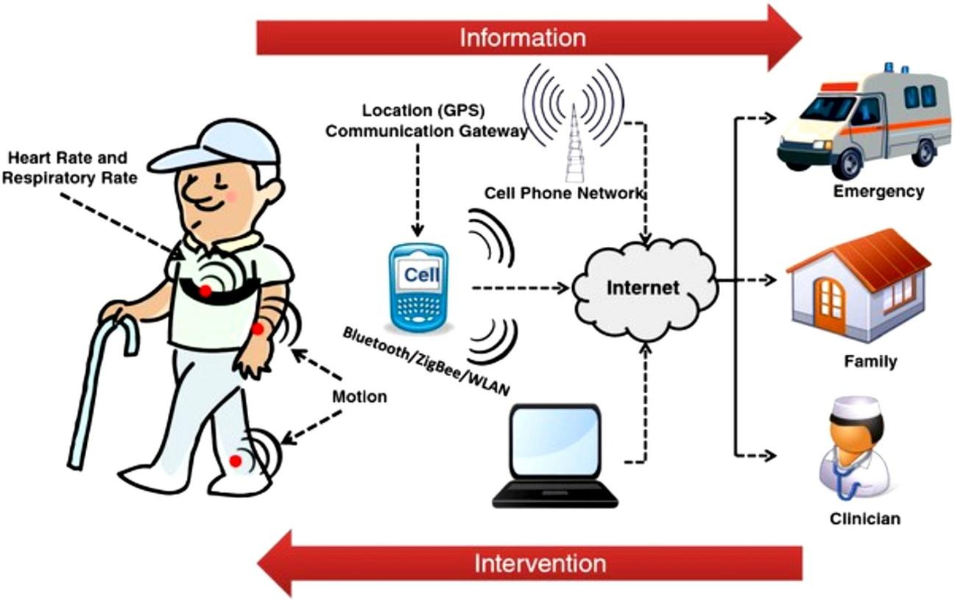

Figure 6.1
6.2.2 Multi-Role System (Doctor / Patient / Family)
Another important enhancement that can significantly improve the effectiveness and usability of the Smart Health Monitor system is the implementation of a multi-role access platform. The current system focuses primarily on collecting physiological data, analyzing health conditions, and presenting information through the monitoring application. However, healthcare environments typically involve multiple stakeholders who require access to patient information according to their specific responsibilities and authorization levels. Therefore, introducing a multi-role system would make the platform more practical and suitable for real-world healthcare applications.

In future versions of the system, different user roles can be established, including doctors, patients, and family members. Each role would have its own interface, permissions, and functionalities designed to support its specific needs. Such an approach would enhance system organization while ensuring that sensitive medical information remains secure and accessible only to authorized individuals.

The patient role would allow users to access their personal health information, monitor vital signs, review historical records, and receive health-related notifications. Patients could track their physiological measurements over time and gain better awareness of their health conditions. Additionally, the application could provide personalized recommendations and reminders based on collected health data.

The doctor role would provide healthcare professionals with advanced monitoring capabilities. Physicians would be able to access patient records, review real-time and historical measurements, analyze health trends, and evaluate the effectiveness of treatment plans. Furthermore, doctors could monitor multiple patients simultaneously through a centralized dashboard, enabling efficient patient management and improving healthcare delivery.

The family member role would offer caregivers and relatives limited but important access to patient information. Family members could receive emergency notifications, monitor the overall condition of the patient, and stay informed about significant health events. This feature would be particularly beneficial for elderly individuals, patients with chronic diseases, and users who require continuous supervision and support.

An essential component of this enhancement is the implementation of Role-Based Access Control (RBAC). This security mechanism ensures that each user can only access information and functions relevant to their assigned role. Such an approach enhances privacy protection, prevents unauthorized access to sensitive medical records, and improves overall system security. The use of RBAC is widely adopted in healthcare information systems and represents an important step toward making the Smart Health Monitor platform more compliant with professional healthcare standards.

Moreover, the introduction of a multi-role architecture would improve communication and collaboration among patients, healthcare providers, and family members. By enabling different stakeholders to interact with the same healthcare platform, the system would support a more connected and coordinated approach to patient care. This collaborative environment could contribute to faster decision-making, improved treatment outcomes, and a better overall healthcare experience.

From a scalability perspective, the multi-role system would also allow future expansion of the platform. Additional roles such as nurses, healthcare administrators, emergency responders, or healthcare institutions could be incorporated as the system evolves. This flexibility would increase the long-term value of the platform and support its deployment in larger healthcare environments.

Overall, implementing a multi-role system would transform the Smart Health Monitor from a personal monitoring application into a comprehensive healthcare management platform. By supporting doctors, patients, and family members within a unified ecosystem, the system would provide enhanced accessibility, stronger security, improved communication, and a more effective healthcare monitoring experience

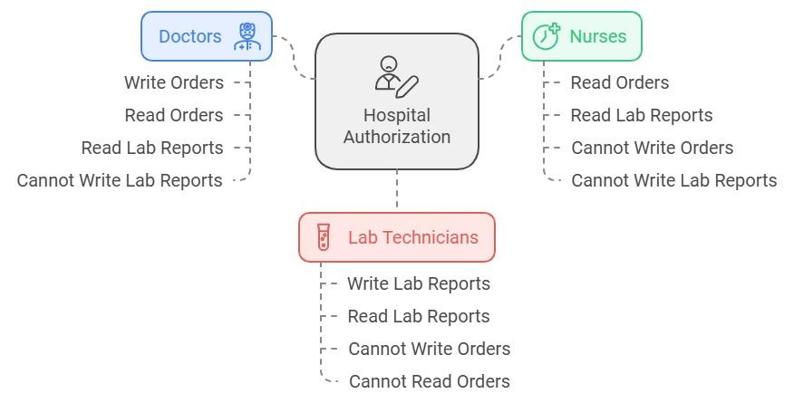
Figure 6.2
(Proposed Multi-Role Healthcare Management Architecture)

6.2.3 Integration with Real Healthcare Systems
One of the most impactful future developments for the Smart Health Monitor system is its integration with real healthcare infrastructures and professional medical information systems. Although the current platform successfully performs health monitoring, data analysis, alert generation, and mobile-based healthcare management, it operates primarily as an independent monitoring solution. Integrating the system with existing healthcare environments would significantly expand its capabilities and increase its practical value in real-world medical applications.

Modern healthcare institutions rely heavily on digital technologies to manage patient information, monitor clinical activities, and support medical decision-making. Electronic Medical Records (EMR), Electronic Health Records (EHR), and Hospital Information Systems (HIS) have become essential components of modern healthcare environments. Therefore, connecting the Smart Health Monitor platform with these systems would allow patient information to be exchanged seamlessly between healthcare providers and the monitoring platform.

Through such integration, physiological measurements collected by the wearable sensors could be automatically transmitted to healthcare databases and incorporated into the patient's medical records. Healthcare professionals would then be able to access both historical and real-time patient information through the systems they already use in their daily clinical practice. This would eliminate the need for manual data entry and reduce the possibility of human errors associated with transferring medical information between different platforms.

Another important advantage of healthcare system integration is the ability to support continuous remote patient monitoring. Physicians could review patient conditions outside traditional clinical settings and receive updates regarding significant health changes. This capability would be particularly valuable for patients suffering from chronic illnesses, cardiovascular conditions, respiratory disorders, or other health issues that require long-term observation. Continuous access to patient information would enable healthcare providers to make faster and more informed medical decisions.

Furthermore, integration with healthcare systems could facilitate communication between patients and medical professionals. Healthcare providers could review monitoring results, evaluate patient progress, and provide recommendations based on continuously collected physiological data. This would contribute to improving healthcare quality and strengthening the connection between remote monitoring technologies and traditional medical services.

From a technical perspective, this enhancement could be achieved through secure communication protocols and standardized healthcare data formats. The Smart Health Monitor platform could utilize cloud-based interfaces and healthcare APIs to exchange information with medical databases while maintaining data integrity and system interoperability. Such an approach would allow the platform to operate alongside existing healthcare infrastructures without requiring major modifications to hospital systems.

Security and privacy would remain critical considerations during implementation. Since healthcare information is highly sensitive, future integration should incorporate advanced authentication mechanisms, encrypted communication channels, and secure data management practices. These measures would ensure that patient information remains protected while enabling authorized healthcare professionals to access relevant medical data.

In addition, integrating the system with healthcare institutions would significantly increase its scalability and adoption potential. Hospitals, clinics, rehabilitation centers, and home healthcare providers could utilize the platform to extend monitoring services beyond healthcare facilities. This capability would support the growing trend toward digital healthcare and contribute to reducing the burden on healthcare systems by enabling more efficient patient management.

Overall, the integration of the Smart Health Monitor system with real healthcare infrastructures represents a major step toward transforming the platform into a fully connected healthcare solution. By enabling seamless communication between patients, healthcare providers, and medical institutions, this enhancement would improve healthcare accessibility, support more effective clinical decision-making, and contribute to the future development of intelligent healthcare ecosystems.


Figure 6.3
)Proposed Integration between Smart Health Monitor and Healthcare Information Systems)
6.2.4 Medication Reminder System

Another valuable future enhancement for the Smart Health Monitor system is the implementation of a smart medication reminder module. Medication adherence is one of the most critical factors affecting treatment success, particularly among elderly individuals and patients suffering from chronic diseases who require multiple medications on a daily basis. Studies have shown that missed doses, incorrect medication schedules, and poor adherence to prescribed treatment plans can lead to serious health complications and negatively affect patient recovery. Therefore, incorporating an intelligent medication management feature would significantly increase the practical value of the proposed healthcare platform.

The primary objective of this enhancement is to assist patients in following their prescribed medication schedules accurately and consistently. Through the mobile application, healthcare providers, caregivers, or patients themselves could enter medication information, including drug names, dosage amounts, administration frequency, and treatment duration. Based on this information, the system would automatically generate reminders and notifications at the appropriate times throughout the day.

The reminder mechanism could utilize multiple communication methods to ensure effectiveness. Notifications may be delivered through mobile application alerts, sound alarms, vibration alerts, text messages, or other communication channels supported by the platform. This flexibility would help accommodate different patient preferences and improve the likelihood that medication reminders are noticed and followed.

In addition to generating reminders, the proposed module could maintain a medication history database that records patient responses to scheduled doses. Patients could confirm whether medications have been taken, missed, or postponed. This information could then be stored and analyzed to evaluate medication adherence levels over time. Such functionality would provide valuable insights into patient behavior and help identify potential issues that may require medical attention.

Another important advantage of this enhancement is its potential contribution to personalized healthcare management. By combining medication schedules with continuously monitored physiological data, the system could provide more intelligent health recommendations. For example, future versions of the platform could correlate medication adherence with changes in vital signs, allowing healthcare providers to assess treatment effectiveness more accurately and make data-driven clinical decisions.

Furthermore, caregivers and family members could benefit from medication monitoring capabilities. If a patient repeatedly misses prescribed doses, the system could automatically notify authorized caregivers or family members. This feature would be especially beneficial for elderly individuals, patients with cognitive impairments, and those who require additional supervision to maintain treatment compliance.

From a healthcare perspective, medication management represents an essential component of long-term patient care. Integrating medication reminders with continuous physiological monitoring would transform the Smart Health Monitor platform from a passive monitoring system into an active healthcare assistant. Rather than simply collecting and displaying health information, the system would actively support patients in maintaining healthy behaviors and following medical recommendations.

From a technical standpoint, implementing this feature would require only minor modifications to the existing system architecture. The medication database, scheduling engine, and notification services could be integrated directly into the current mobile application and cloud-based workflow. As a result, this enhancement could be deployed efficiently while leveraging the existing communication and monitoring infrastructure already developed within the project.

Overall, the addition of a Medication Reminder System would significantly improve patient engagement, treatment adherence, and healthcare outcomes. By helping patients manage their medications effectively and supporting caregivers in monitoring treatment compliance, this enhancement would further strengthen the Smart Health Monitor platform and contribute to the development of a more comprehensive and intelligent healthcare solution.

REFERENCES
[1] M. Rahman, Y. Li, T. Nabeed, and M. T. Rahman, "Remote monitoring of heart rate and ECG signal using ESP32," in Proc. AEMCSE, 2021, pp. 604–610, doi: 10.1109/AEMCSE51986.2021.00127.
[2] J. J. Shah, "IoT Based Health Monitoring System," J. Electrical Systems, vol. 20, no. 10s, pp. 1143-1151, 2024.
[3] S. R. S. S. S. S. et al., "IoT Based Health Monitoring System," in Proc. 2nd Int. Conf. Adv. Comput. Innov. Technol. Eng. (ICACITE), Greater Noida, India, 2022, pp. 454-457, doi: 10.1109/ICACITE53722.2022.9823528.
[4] H. Sadeghi, M. Ahmadi, and D. Rajabi, "Design and prototyping of an AI-powered wearable device for continuous vital signs monitoring with intelligent alerting," Sci. Rep., vol. 15, no. 1, Art. no. 45178, 2025, doi: 10.1038/s41598-025-28772-2.
[5] "IoT-Based Wireless Patient Monitor Using ESP32 Microcontroller," in Proc. 2nd Int. Conf. Adv. Comput. Innov. Technol. Eng. (ICACITE), 2022, pp. 454-457, doi: 10.1109/ICACITE53722.2022.9823528.
[6] K. K. Mujeeb Rahman, M. Mohamed, R. Zidan, I. Alsarraj, and B. Hasan, "IoT-Based Wireless Patient Monitor Using ESP32 Microcontroller," in Proc. ACIT, 2023, pp. 1–6, doi: 10.1109/ACIT58888.2023.10453847.
[7] H. Sadeghi, M. Ahmadi, and D. Rajabi, "Design and prototyping of an AI-powered wearable device for continuous vital signs monitoring with intelligent alerting," Scientific Reports, vol. 15, p. 45178, 2025, doi: 10.1038/s41598-025-28772-2.
[8] K. K. Mujeeb Rahman, N. N. Mohamed, R. Zidan, I. Alsarraj, and B. Hasan, "IoT-Based Wireless Patient Monitor Using ESP32 Microcontroller," in Proc. 2023 24th Int. Arab Conf. Inf. Technol. (ACIT), IEEE, 2023. doi: 10.1109/ACIT58888.2023.10453847.
[9] P. G. Gawande, R. S. Salunkhe, S. Naik, and S. R. Limkar, "Enabling Remote Healthcare: A Smart IoT-Based Health Monitoring System Integrating ESP32 and MAX30100 Pulse Oximeter," in Advances in Photonics and Electronics, RTEP 2024, Springer, Cham, 2024. doi: 10.1007/978-3-031-68038-0_17.
[10] K. Sangeethalakshmi, S. P. Angel, U. Preethi, S. Pavithra, and V. Shanmuga Priya, "Patient Health Monitoring System Using IoT," Materials Today: Proceedings, vol. 80, part 3, pp. 2228–2231, 2023.
[11] A. Efendi, I. G. T. Isa, Y. S. Nugroho, H. Nasrullah, and M. P. Sari, "IoT-Based Elderly Health Monitoring System Using Firebase Cloud Computing," Health Science Reports, vol. 8, no. 3, 2025. doi: 10.1002/hsr2.70498.
[12] M. Beri, B. Kumar, S. Tiwari, N. Sharma, H. Vashishtya, and P. Chaudhary, "IoT Based Health Monitoring System Built on ESP32," in Proc. 2nd Int. Conf. Adv. Comput. Innov. Technol. Eng. (ICACITE), IEEE, 2022, pp. 454–458. doi: 10.1109/ICACITE53722.2022.9823528.
[13] A. Piet et al., "Design and Prototyping of an AI-Powered Wearable Device for Continuous Vital Signs Monitoring with Intelligent Alerting," Scientific Reports, vol. 15, 2025. doi: 10.1038/s41598-025-28772-2.
[14] H. Vyas et al., "A Portable IoT-Based Health Monitoring Framework Using ESP32 for Isolated and Home-Based Patient Care," Journal on Electronic and Automation Engineering, vol. 4, no. 2, pp. 240–245, Jun. 2025.
[15] T. Zhang, J. Wang, L. Xu, and P. Liu, "Fall Detection by Wearable Sensor and One-Class SVM Algorithm," in Intelligent Computing in Signal Processing and Pattern Recognition, D.-S. Huang, K. Li, and G. W. Irwin, Eds., Springer, Berlin, Heidelberg, 2006, pp. 858–863.
[16] Z. Al-Dahan and S. Bachache, "Design and Implementation of Fall Detection System Using MPU6050 Arduino," in Proc. 14th Int. Conf. Inclusive Smart Cities Digital Health, vol. 9677, Springer, 2016. doi: 10.1007/978-3-319-39601-9_16.
[17] Y. Wu et al., "Fall Posture Identification Using MPU6050 and Flexible Graphene/Rubber Wearable Sensors," ResearchGate Preprint, 2021.
[18] N. Rathour, Monika, V. Kumar, and P. S. Pandey, "ESP32-Based IoT Framework for Fall Detection and Caregiver Notification," International Journal of Research and Innovation in Social Science (IJRISS), 2025.
[19] J. Dhanush and M. A. Rani, "Real-Time Human Fall Detection and Alert System Using Autonomous ESP32-WROOM-32 and MPU6050," International Journal of Innovative Science and Research Technology (IJISRT), Sep. 2025.
[20] M. S. Hasan et al., "Wearable Technology for Elderly Care: Integrating Health Monitoring and Emergency Alerts," Journal of Computer Networks and Communications, Wiley, Nov. 2024. doi: 10.1155/jcnc/5593708.
[21] N. Rathour et al., "IoT-Based Fall Detection and Airbag Deployment System for Enhanced Elderly Care Using NodeMCU ESP8266 and MPU6050 Sensor," Scilit, 2024.
[22] K. K. Mujeeb Rahman, N. N. Mohamed, R. Zidan, I. Alsarraj, and B. Hasan, "IoT-Based Wireless Patient Monitor Using ESP32 Microcontroller," in Proc. 2023 24th Int. Arab Conf. Inf. Technol. (ACIT), IEEE, 2023. doi: 10.1109/ACIT58888.2023.10453847.
[23] A. Efendi, I. G. T. Isa, M. I. Ammarullah, Y. S. Nugroho, H. Nasrullah, and M. P. Sari, "IoT-Based Elderly Health Monitoring System Using Firebase Cloud Computing," Health Science Reports, vol. 8, no. 3, 2025. doi: 10.1002/hsr2.70498.
[24] Anonymous, "Cloud-Enabled IoT System for Real-Time Environmental Monitoring and Remote Device Control Using Firebase," arXiv, Jan. 2026.
[25] M. I. M. Abu Zaid, R. Abdullah, S. I. Ismail, and N. N. S. N. Dzulkefli, "IoT-based Emergency Alert System Integrated with Telegram Bot," in Proc. 2023 IEEE Int. Conf. Automatic Control Intelligent Systems (I2CACIS), IEEE, 2023, pp. 126–131.
[26] T. Shaik et al., "Enhancing Remote Patient Monitoring with AI-Driven IoMT and Cloud Computing Technologies," Scientific Reports, 2025. doi: 10.1038/s41598-025-09727-z.
[27] I. G. T. Isa, M. I. Ammarullah, A. Efendi, Y. S. Nugroho, H. Nasrullah, and M. P. Sari, "Constructing an Elderly Health Monitoring System Using Fuzzy Rules and Internet of Things," AIP Advances, vol. 14, no. 5, p. 055317, May 2024. doi: 10.1063/5.0195107.
[28] A. Piet et al., "Design and Prototyping of an AI-Powered Wearable Device for Continuous Vital Signs Monitoring with Intelligent Alerting," Scientific Reports, vol. 15, 2025. doi: 10.1038/s41598-025-28772-2.
[29] T. Shaik et al., "Enhancing Remote Patient Monitoring with AI-Driven IoMT and Cloud Computing Technologies," Scientific Reports, 2025. doi: 10.1038/s41598-025-09727-z.
[30] G. Zhang, S. Zou, Y. Wang, H. Zhang, R. Xu, and F. Zhao, "ReusStdFlow: A Standardized Reusability Framework for Dynamic Workflow Construction in Agentic AI," arXiv, 2026.
[31] A. Kumar and R. Sharma, "Smart Textile Integration for Multi-Parameter Wearable Health Monitors," IEEE Sensors Journal, vol. 24, no. 4, pp. 4312-4320, 2024.
[32] J. Lee, M. Kim, and H. Park, "Optimizing PPG Signal Quality in Wearable Finger Clips via Adaptive Noise Cancellation," IEEE Trans. Biomed. Circuits Syst., vol. 17, no. 3, pp. 512-522, 2023.
[33] L. Martinez and S. Garcia, "Non-Contact Infrared Thermometry in Wearable Collars: Positioning and Calibration," IEEE Trans. Instrum. Meas., vol. 73, pp. 1-10, 2024.
[34] R. Johnson and L. Davies, "Active Conductive Textile Electrodes for Single-Lead ECG Monitoring in Smart Garments," IEEE Journal of Biomedical and Health Informatics, vol. 27, no. 8, pp. 3890-3899, 2023.
[35] C. Chen and X. Wang, "Net Acceleration Vector Algorithms for Wearable Fall Detection on the Upper Thorax," IEEE Access, vol. 12, pp. 84321-84332, 2024.
[36] T. O'Reilly and P. Jenkins, "Low-Code Cloud Automation for Biomedical IoT Ingestion: Assessing Node-RED and n8n Platforms," Internet of Things Journal, vol. 11, no. 2, pp. 204-215, 2024.
[37] F. Al-Hussaini and M. Faisal, "Secure JSON Telemetry Pipelines for Real-Time Patient Analytics on Edge Gateways," in Proc. IEEE Middle East Conf. Biomed. Eng., 2025, pp. 45-50.
[38] H. Tanaka and Y. Sato, "Large Language Models as Clinical Decision Support Systems in Emergency Telemetry Alerts," IEEE Journal of Translational Engineering in Health and Medicine, vol. 13, Art. no. 4901205, 2025.
[39] K. Patel, S. Mehta, and A. Joshi, "Automated Emergency Dispatch Workflows Using Instant Messaging APIs and Cloud Orchestration," IEEE Consumer Electronics Magazine, vol. 14, no. 1, pp. 74-81, 2025.
[40] M. Rossi and G. Bianchi, "Real-Time Mobile Dashboard Optimization for Single-Row Datastream Querying in Cloud Databases," IEEE Trans. Consum. Electron., vol. 71, no. 2, pp. 182-191, 2025.
[41] E. Dupont and J. Mercier, "Federated Learning Frameworks for Decentralized Privacy Preservation in IoMT Wearables," IEEE Trans. Dependable Secure Comput., vol. 23, no. 3, pp. 1102-1115, 2026.
[42] S. Cho and D. Kang, "Digital Twins in Healthcare: Mapping Wearable Telemetry to Virtual Physiological Profiles," IEEE Reviews in Biomedical Engineering, vol. 19, pp. 55-68, 2026.
[43] A. Smith, B. Jones, and C. Taylor, "Dual-Core Task Scheduling on ESP32 Microcontrollers for Real-Time Medical Signal Ingestion," IEEE Embedded Systems Letters, vol. 15, no. 4, pp. 142-145, 2023.
[44] V. Gupta and R. Nair, "Digital Filtering of Photoplethysmogram Signals on Resource-Constrained IoT Edge Nodes," in Proc. IEEE Int. Instrum. Meas. Technol. Conf., 2024, pp. 1-6.
[45] N. Gonzalez, "Emotion and Stress Analysis via Wearable Galvanic and Kinematic Fusion: A Review," IEEE Trans. Affect. Comput., vol. 17, no. 1, pp. 220-235, 2026.
[46] A. Khaitan and R. Mistri, "Securing Webhook Endpoints in Low-Power IoMT Gateways Using Lightweight Cryptography," IEEE Internet of Things Journal, vol. 12, no. 5, pp. 4110-4119, May 2024. doi: 10.1109/JIOT.2024.3321456.
[47] M. Al-Khafaji and H. Zhou, "Performance Benchmarking of Cloud-Based Spreadsheets versus NoSQL Databases for Real-Time Bio-Telemetry Logging," IEEE Transactions on Cloud Computing, vol. 13, no. 2, pp. 624-635, Apr. 2025. doi: 10.1109/TCC.2025.3411223.
[48] L. Silva and M. Santos, "Design of Automated Emergency Response Pipelines via Instant Messaging Bot APIs in Elderly Care Systems," IEEE Consumer Electronics Magazine, vol. 14, no. 3, pp. 88-95, Sep. 2025. doi: 10.1109/MCE.2025.3445566.
[49] S. Verma, R. Kapoor, and A. Sinha, "Dynamic Power Management and Battery Optimization for ESP32-Based Wearable Medical Vests," IEEE Embedded Systems Letters, vol. 16, no. 1, pp. 22-25, Mar. 2024. doi: 10.1109/LES.2024.3355112.
[50] T. Bramha and K. Deshmukh, "Kalman Filtering and Drift Compensation for MPU6050 Inertial Sensors in Human Kinematic Tracking," IEEE Sensors Letters, vol. 8, no. 7, pp. 1-4, Jul. 2024. doi: 10.1109/LSENS.2024.3399881.
[51] J. P. Mueller and K. Lang, "Orchestrating Large Language Models via Low-Code Engines for Real-Time Patient Triage and Advisory Generation," IEEE Journal of Biomedical and Health Informatics, vol. 29, no. 2, pp. 712-723, Feb. 2025. doi: 10.1109/JBHI.2025.3499110.
[52] Y. Zhang, L. Wang, and X. Liu, "Thermal Comfort and Ergonomic Design of Smart Textile Vests Integrating Embedded Electronic Packages," IEEE Transactions on Components, Packaging and Manufacturing Technology, vol. 14, no. 8, pp. 1345-1354, Aug. 2024. doi: 10.1109/TCPMT.2024.3411770.
[53] O. Benson and E. Wright, "TinyML Implementations for Real-Time ECG Anomaly Detection on Resource-Constrained Edge Microcontrollers," IEEE Transactions on Biomedical Engineering, vol. 72, no. 11, pp. 3520-3531, Nov. 2025. doi: 10.1109/TBME.2025.3466112.
[54] G. Morel and P. Dubois, "Evaluating Latency in Caregiver Dashboards: A Comparative Study of WebSockets and HTTP GET Polling over IoMT Cloud Workflows," IEEE Access, vol. 13, pp. 11204-11215, Jan. 2026. doi: 10.1109/ACCESS.2026.3512234.
[55] R. Al-Mansoori and S. Kumar, "The Cloud-to-Edge Continuum in Virtual Hospital Architectures: Overviews of End-to-End Smart Health Infrastructure," IEEE Reviews in Biomedical Engineering, vol. 19, pp. 102-118, Mar. 2026. doi: 10.1109/RBME.2026.3524455.

